**E-COLLECT**

**USER MANUAL**

# Amendment History

|  |  |  |
| --- | --- | --- |
| Revision Date | Version | Description |
| March 2016 |  | Review after system enhancements |
| June 2016 |  | Review after system enhancements |
| June 2020 |  | Sprint 3 items |
| July 2020 |  | Service providers added |
| July 2020 | 4.0.1 | Service provider request processing updated  IT Support section  Reports |

Contents

Amendment History 1

 INTRODUCTION 4

1.1 Key functional benefits 4

1.2 Allocation criteria 4

1.2.1. ARO/RRO Code 4

1.2.2 Buckets 4

1.2.3. Regions 4

1.2.4 Cycles 5

1.2.5 Product code 5

1.3.5 Summary of allocations 6

1.2.6 Allocation prioritization 14

2.0 USING THE SYSTEM 16

2.1 System access 16

2.2 Dashboard components 17

2.3 Loans queue 17

2.4 Broken promises 20

2.5 E-Credit 20

2.6 Service Providers 20

3.0 Collector activity 22

3.1 Change in actioning an account 22

3.2 Collector activity sections 23

3.2.1 Client Home 23

3.2.2 Notes History 23

3.2.3 Collector activity 24

3.2.4 Demand letters 25

3.2.5 SMS 25

3.2.6 Account Plan 26

3.2.7 Customer contacts 26

3.2.8 Remedial Collaterals 26

3.2.9 Guarantors 27

3.2.10 Upload files 27

3.2.11 Bulk Uploads 28

3.2.12 Promises to Pay 28

4.0 Service providers 29

4.1 Cancellation of Insurance Premium Finance 29

4.2 Repossession order 30

4.2.1 Request for repossession 30

4.2.2 Repossession approval 31

4.2.3 Instruction release 32

4.2.4 Auctioneer follow-up 32

4.2.5 Storage yard 32

4.2.6 Valuation 32

4.2.7 Marketing 32

4.3 Investigations 32

4.3.1 Request for investigation 33

4.3.2 Assign & release for investigation 33

4.4 External debt collectors 34

4.4.1 New request for external debt collection 34

4.4.2 Update external debt collector case 34

4.5 Write-offs 35

4.5.1 Recommend for write-off 35

4.5.2 Process write-offs 36

4.6 Invoices 36

4.6.1 New invoice 36

4.6.2 Print invoice 37

5.0 REPORTS 37

6.0 System Administration 38

6.1 User management 38

6.2 Platform metrics 39

6.3 Microservices 39

6.4 Troubleshooting 40

6.4.1 Debugging Pods 40

6.4.2 Debugging Replication Controllers 41

6.4.3 Debugging Services 41

# INTRODUCTION

E-Collect is a debt management system that assists collection department or account relationship manager to track and follow up on non - performing accounts, cards, overdrafts

E-Collet provides financial institutions with unparallel credit management and debt collection functionality. Through analysis of debtor days in arrears, cash flow and the ability to track collections are key benefits quickly delivered by E-Collect

## 1.1 Key functional benefits

* Automated collection processes
* Electronic distribution
* Transaction collection status
* Prompts for follow up actions
* Streamline collection activities
* User diaries
* Payment plans
* Account plans
* Service provider management

## 1.2 Allocation criteria

Allocation criteria refers to the way the system has been set up to automatically identify and distribute accounts and cards amongst existing collectors.

Each business line has an allocation criterion. the following are the types of allocation criteria:

### 1.2.1. ARO/RRO Code

This uses the ARO/RRO code to determine which account should be given to a particular collector. The collectors that use this criterion are:

* + - CMD Recoveries
    - Corporate
    - Co-operatives: includes Sacco main and Transport and housing
    - Agribusiness

### 1.2.2 Buckets

This allocation criterion groups and allocates accounts depending on the number of days in arrears.

One can have several buckets. e.g. loans in arrears between 30 – 60 days can be considered to be in one bucket. This bucket is then allocated to one or more collectors.

The collectors that use this criterion are:

* + - Personal Loans Scheme loans
    - Personal Loan Scored loans
    - E- Credit

### 1.2.3. Regions

This allocation criterion allows the users to create a region, assign branches to the region, and allocate the region to one collector. The system identifies the accounts that are to be grouped in regions by their memo group.

The collection domains that use this mode of allocation are:

* + - Micro credit
    - SME
    - Portfolio management
    - M-Coop Cash

### 1.2.4 Cycles

This allocation criterion is only for credit cards. The collection domains that use this mode of allocation are:

* + - Remedial card recoveries
    - Collections card unit

### 1.2.5 Product code

This allocation criterion is used by CMD Portfolio management.

### 1.3.5 Summary of allocations

|  |  |  |  |
| --- | --- | --- | --- |
|  | Collector  Base | Group criteria | Allocation rules |
| PERSONAL LOANS – SCORED | Collections department | These are accounts with the following characteristics:   1. Memo group is 6E9,680,9E7,6E7,9K4,,9D3,653,6K3,or 6D3 2. If the account is a loan i.e. its memo group is 9D3, 9K3, 9E7, 9E9 and 6E9; then account should be 7+ days in arrears | 1. Accounts are allocated per customer number i.e. all accounts with similar customer numbers are allocated to one collector. 2. After grouping the accounts with similar customer numbers together, the account with the highest number of days in arrears determines the bucket into which the account falls. |
|  |  | iii. Memo 653, 6K3, 6D3 and 680 will be automatically assigned to the 60 – 89 days bucket | iii. The system will use an inbuilt load balance mechanism to distribute the accounts that fall into the same category to all the collectors of that category. |
|  |  |  | iv. The system redistributes the accounts every day depending on their bucket. |
| PERSONAL LOANS – SCHEME LOANS | Collections Department | These are accounts with the following characteristics:  i. Memo group is 6E8,655,6F2,6C7,626,650,630 or 633 | i. Accounts are allocated per customer number i.e. all accounts with similar customer numbers are allocated to one collector |
|  |  | ii. After grouping the accounts with similar |

|  |  |  |  |
| --- | --- | --- | --- |
|  | Collector  Base | Group criteria | Allocation rules |
|  |  | ii. If the account is a loan i.e. memo 6E8, 6F2 or 6C7, then the loan should be 30+ days   1. Memo 650, will only be allocated if:    * If the customer has a loan with memo 6E8, 6F2 or 6C7, and it is 60+ days in arrears   **OR**   * + The customer has a 650 account but does not have an account in E – Collect with memo 6E8, 6F2 or 6C7 i.e. the loan is cleared   **NB:**   * + - It is assumed that memo 650 is only used together with scheme loans; however, it is known that there are a few asset finance loans that were allocated this memo (see appendix). These have been manually been reallocated to the appropriate collectors.     - Memo 650 will not be allocated if its corresponding loan account has not been placed in any bucket since it is assumed that it does not meet the criteria to be allocated e.g. if it is less than 60 days in arrears  1. Memo 655, 626, 630 and 630 will always be considered to be 60 – 89 days in arrears and will always be allocated. | customer numbers together, the account with the highest number of days in arrears determines the bucket into which all other accounts belonging to the customer, will be placed. E.g. if the customer has a memo 650 and a 6F2 which is 30 days in arrears; then this loan will be placed in the bucket that the 650 account will be placed i.e. 60 – 89 days   1. If the customer has a 6F2 loan which is 25 days in arrears, and a 655 account, then the system will only allocate the 655 account and not the 6F2, unless a bucket that can accommodate the 25 days in arrears bracket exists (e.g. 1 – 30 days). However, the account will be available for viewing if required. 2. The system will use an inbuilt load balance mechanism to distribute the accounts that fall into the same category to all the collectors of that category. 3. The system redistributes the accounts every day depending on their bucket. |
| CREDIT CARD COLLECTIONS | Collections Departmen t | Collections credit card collectors are allocated cards in Cycle 7,9,11 and 16. | 1. Cards are distributed among the existing collectors using a load balance mechanism 2. The has to fulfil the following conditions for it to be allocated:    * Card is in arrears   **AND**   * + Card is in active status i.e. not dormant |
| CREDIT CARD REMEDIAL | Remedial department | Remedial credit card collectors are allocated all cards in Cycle 17  i. Cycle 17 is allocated to Collectors in Remedial Department regardless of the card balance or status.  **NB:** | 1. Cards are distributed among the existing collectors using a load balance mechanism 2. All cycle 17 cards are in E – collect regardless of their balance or status |

|  |  |  |  |
| --- | --- | --- | --- |
|  | Collector  Base | Group criteria | Allocation rules |
|  |  | Zero balance and cards in credit for cycle 17 cards are placed in a pool – they are not allocated to a particular collector   | iii. Zero balance cards and cards in credit are placed in a pool. They are not allocated to a collector |
| CORPORATE | Collections Departmen t | Corporate loans are loans whose ARO code starts with CORP.  And memo 6E6 and 6L9, 619,620,652 | i. Accounts are grouped per customer then allocated to one collector |
|  |  | These are allocated to the Corporate collector except for: exceptions: |
|  |  | i. Accounts with CORP ARO code but have an Asset Finance, IPF or Mortgage memo group. (see |
|  |  | **OR** |
|  |  | ii. The account is not a loan account i.e. it is a liability account |
| MICRO CREDIT | Corporate Departmen  t | Micro credit accounts have the following memo groups: | i. Microcredit loans will be allocated per region |
|  |  | Loan memo: 6L8,6F7,6J2,6B8,7A0,6J1,6B0 and 6F6  Loan OD memo: 637,667,698,656,700,618,657 | ii. Each collector will be allocated a region which will consist of several branches, and all the delinquent micro credit accounts in those branches, whose ARO code is not CMDR |
|  |  |  | iii. All Loan OD’s are considered to be in arrears of the outstanding balance |
| SME |  | SME loans are allocated per region. | i. SME loans will be allocated per region |
|  | SME accounts have the following memo groups:  Loan: 6D5,6B7,6C8,7A4,7A3,6H2,6L4,7A5,6K6,  6P0, 6P1, 6P5, 6P6, 6P7, 6K9, 6J6 – 6H3 | ii. Each collector will be allocated a region which will consist of several branches, and all the delinquent SME accounts in those branches, whose ARO code is not CMDR |
|  | Loan OD: 601,600,683,627,641,704,706, |  |
|  |  | iii. All Loan OD’s are considered to be in arrears of the outstanding balance |
| M-COOP CASH | Collections | All E-Credit loans | 1. 8 – 89 Days in arrears allocated to scheme loan collectors as per the current allocation criteria 2. 90+ days in arrears allocated to m-coop cash collector using load   balance mechanism |
| SACCO LOANS  – MAIN | Collections | Sacco main accounts are those whose ARO code starts with SACO | i. Only loan accounts belonging to Sacco  banking will be given to Sacco Main collectors |
|  |  | Memo groups: Loan:  7A1,6C3,6A8,6B6 | ii. Liability accounts and accounts belonging to other units will not be |

|  |  |  |  |
| --- | --- | --- | --- |
|  | Collector  Base | Group criteria | Allocation rules |
|  |  |  | allocated to Sacco main e.g. An |
| Loan OD: | account with an asset finance memo |
| 701,604,614,605,606,615,608,616,622,62 | but with a SACO ARO code, will not be |
| 3,648 | allocated to SACO, but to Asset |
|  | Finance collectors |
| SACCO LOANS  – TRANSPORT HOUSING AND INVESTMENT | Collections | Transport, housing and investment accounts are those whose ARO code starts with THSE | i. Only loan accounts belonging to Transport, housing and Investment will be given to THI collectors |
|  |  | Memo groups:  Loan:  7A1,6C3,6A8,6B6  Loan OD: 701,604,614,605,606,615,608,616,622,62  3,648 | ii. Liability accounts and accounts belonging to other units will not be allocated to THI e.g. An account with an asset finance memo but with a THSE ARO code, will not be allocated to THSE, but to Asset Finance collectors |
| SACCO PERSONAL  LOANS |  | Sacco personal loans will be identified using the memo group | 1. Assigned based on a load balance mechanism to the available collectors 2. All Loan OD’s are considered to be in arrears of the outstanding balance |
|  | Memo groups: Loan:6F3 |
|  | LoanOD:631,634,6J0 |
| AGRIBUSINES |  | Agribusiness loans are those that fulfil the | i. Only loan accounts belonging to |
| S – RM AND | following conditions: | Agribusiness will be given to |
| Branch | i. The ARO code starts with AGBR | Agribusiness Collectors |
|  | ii. They have the following memo groups: | ii. Liability accounts and accounts |
|  | Loans: | belonging to other units will not be |
|  | 7P4,7A2,6L3,6L2,6L1,6K4,6H1,6F4,6C3,6 | allocated to Agribusiness e.g. An |
|  | B3, | account with an asset finance memo |
|  |  | but with a AGBR ARO code, will not be |
|  | LoanOD: | allocated to AGBR, but to Asset |
|  | 127,798,797,796,795,794,793,792,789,78 | Finance collectors |
|  | 4,752,744,739,738,737,723,703,702,693, |  |
|  | 689,688,681,635,622,615,613,609,606,17 |  |
|  | 1,124,123,121,7N9,7N8,7N7,7M3,--754 |  |
| MORTGAGE |  | Mortgage loan accounts are those with the below memo groups: | i. Mortgage will be allocated all accounts with the Mortgage memo group as long as their ARO code does not start with CMD |
|  | Memo groups:  Loan: 9J3,9J8,9J6,9J5,9K0,9K1,9J9,6J3,6J5,9J4  ,6J4 |
|  | Loan OD: 658,679,661 |
| ASSET FINANCE |  | Asset Finance accounts will be identified using the memo group: | i. Delinquent Asset finance accounts will be distributed among the existing  collectors per region |
|  | Memo groups Loans: 6E3,6E2, 6E1  Loan OD 647,649 | ii. If a customer has an IPF and Asset finance loan and they are both in arrears, they will be allocated to the same Asset finance collector |

|  |  |  |  |
| --- | --- | --- | --- |
|  | Collector  Base | Group criteria | Allocation rules |
| IPF – Insurance Premium Financing |  | IPF loans will be identified using the memo group:  Memo groups: Loans:6D0,6B9,6D1,  Loan OD:628, 639, 638 | 1. Delinquent IPF accounts will be distributed among the existing collectors per region 2. If a customer has an IPF and Asset finance loan and they are both in arrears, they will be allocated to Asset Finance collector |
| RECOVERIES |  | Accounts with ARO code starting with CMDR will be allocated to Recoveries. | i. Recoveries will be allocated accounts regardless of their balance, however accounts with zero balance, in credit or with no arrears will be placed in a pool, and not allocated to the respective  collectors |
| CMD CREDIT CARDS |  | All cycle 17 cards are allocated to remedial  credit card collectors regardless of their status | Zero balance and cards in credit will not  be allocated to collectors, but will be placed in a pool |
| CMDP |  | SaMinBal; Savings; CAwOD, 654, memo CMDP | 1. All overdrawn CAwODs will be loaded 2. All Overdrawn saving accounts will be loaded 3. SaMinBal accounts with balances greater than Kes -1000.00 will be loaded. 4. All accounts that do not fall in the above category whose ARO code is CMDP% 5. All overdrawn Call deposits and Fixed deposit accounts 6. All memo 654 will be loaded |

### 1.2.6 Allocation prioritization

For M-Coop Cash

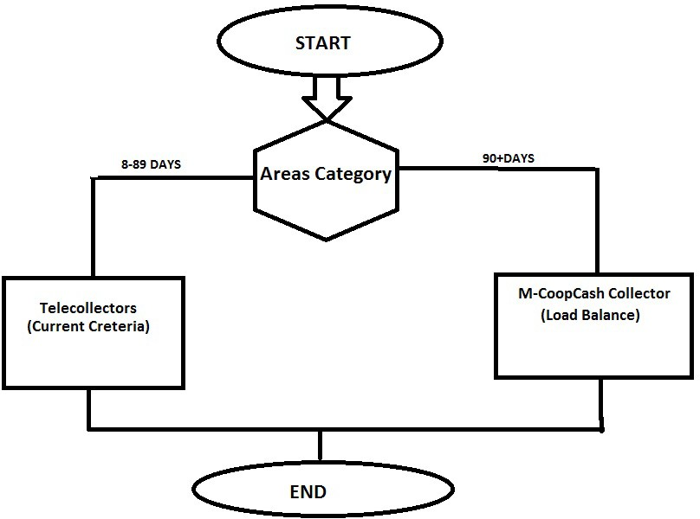



Start

END

Mortgage

PBB scored

MICRO CREDIT

Allocate Asset Finance memos:

PBB scheme

Allocate SME memos

IPF

All accounts with the following Abstract: CAwOD

Calldeposit SaMinBal Savings And

ARO code: CMDP% And

654

All accounts with ARO CODE AGRB%

All accounts with ARO CODE CORP%

All accounts with ARO CODE CMDR%

All accounts with ARO code THS%

All accounts with ARO CODE SACO%

# 2.0 USING THE SYSTEM

## 2.1 System access

* + 1. Copy the URL **https//ecollectweb.co.ke** to the browser tab prevarably chrome browser.
    2. The browsers that support the system are: Mozilla fire fox and Google Chrome, Internet Explorer (10 and up), Microsoft edge.
    3. Log in screen below will appear

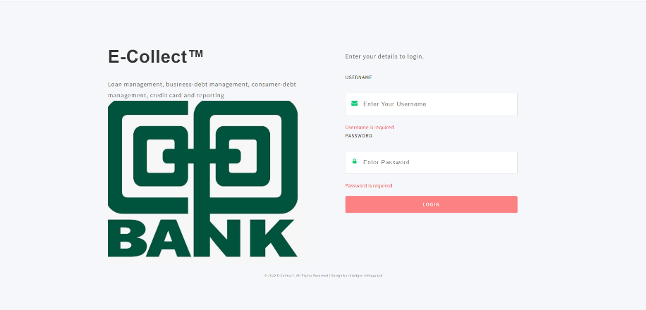

* + 1. Input into the fields, your username and password respectively.
    2. On log in remedial credit department gets the screen below:

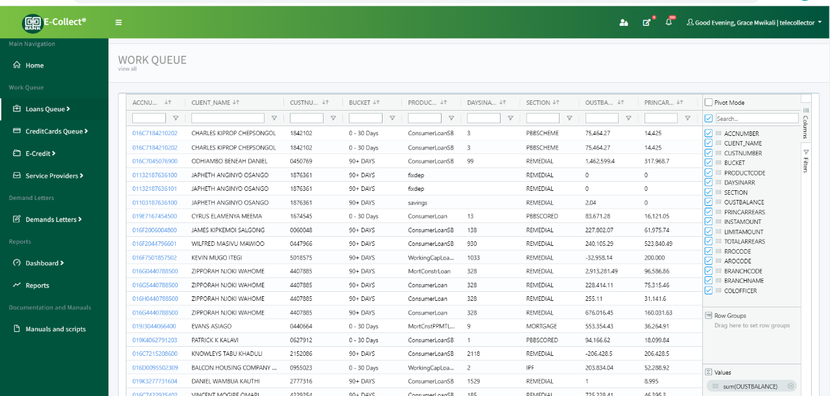

* + 1. Team Leaders get the following screen:

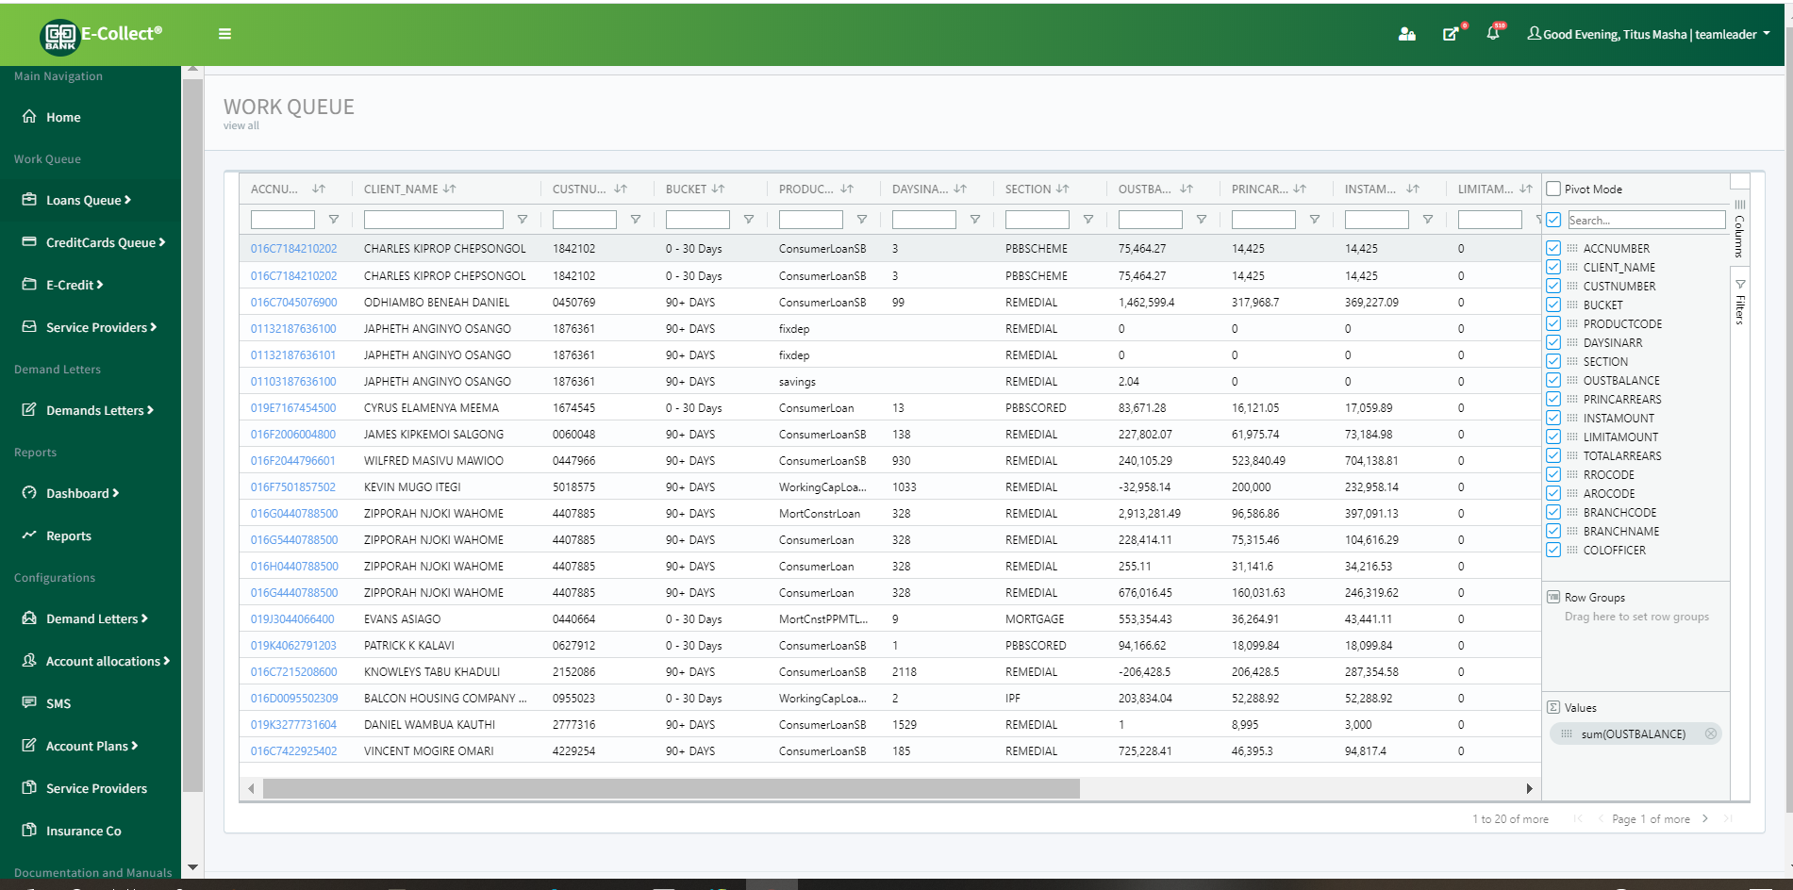

## 2.2 Dashboard components

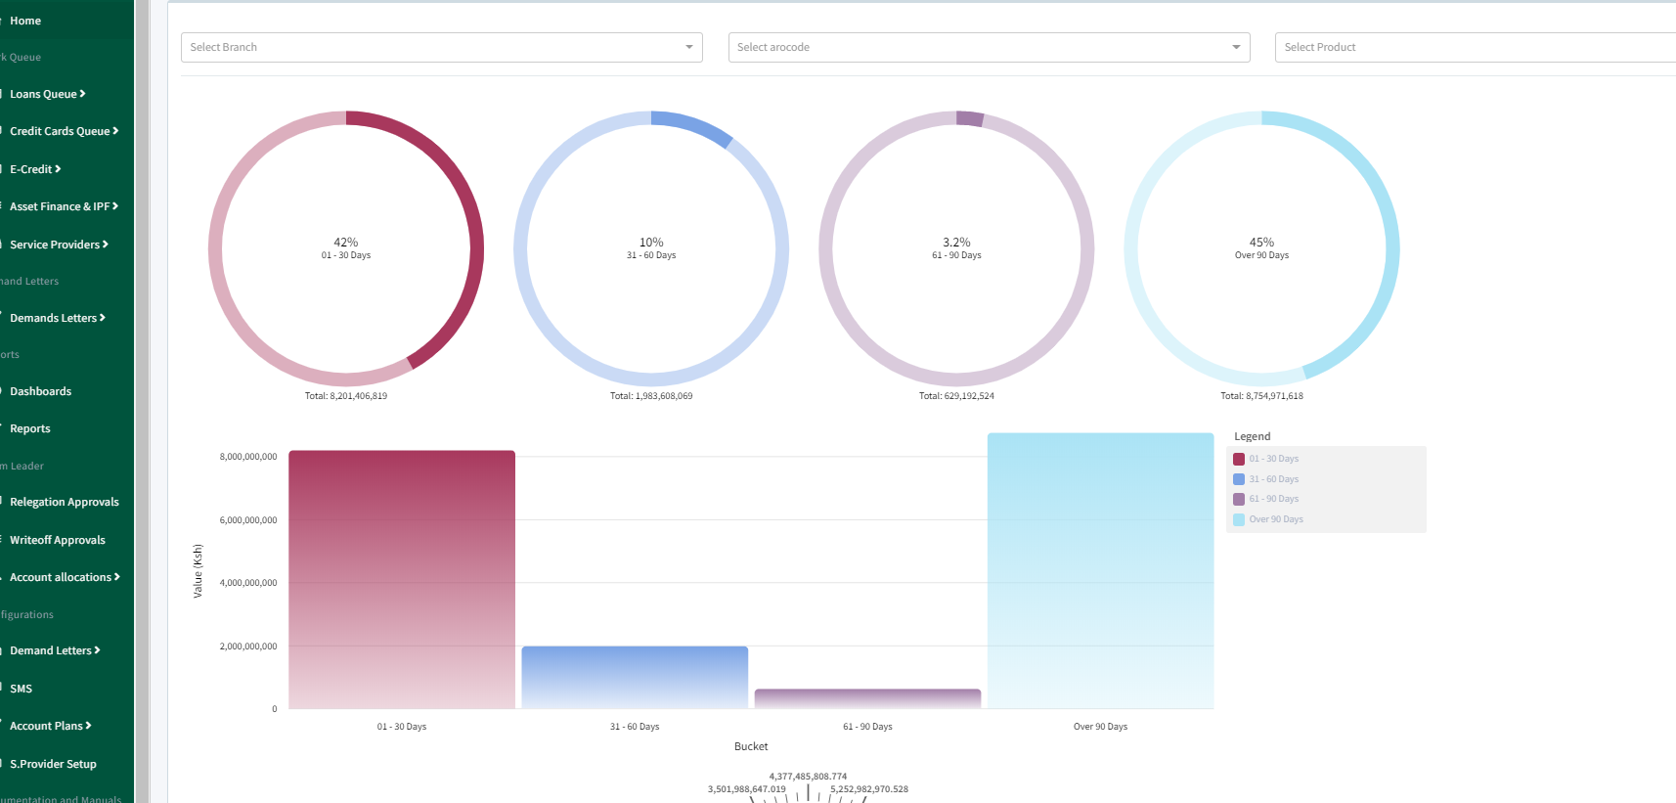

## 2.3 Loans queue

This menu comprises of all the activities a collector does on a loan account.

It consists of loan arrears, my allocation, my worklist, broken promises to pay, transactional 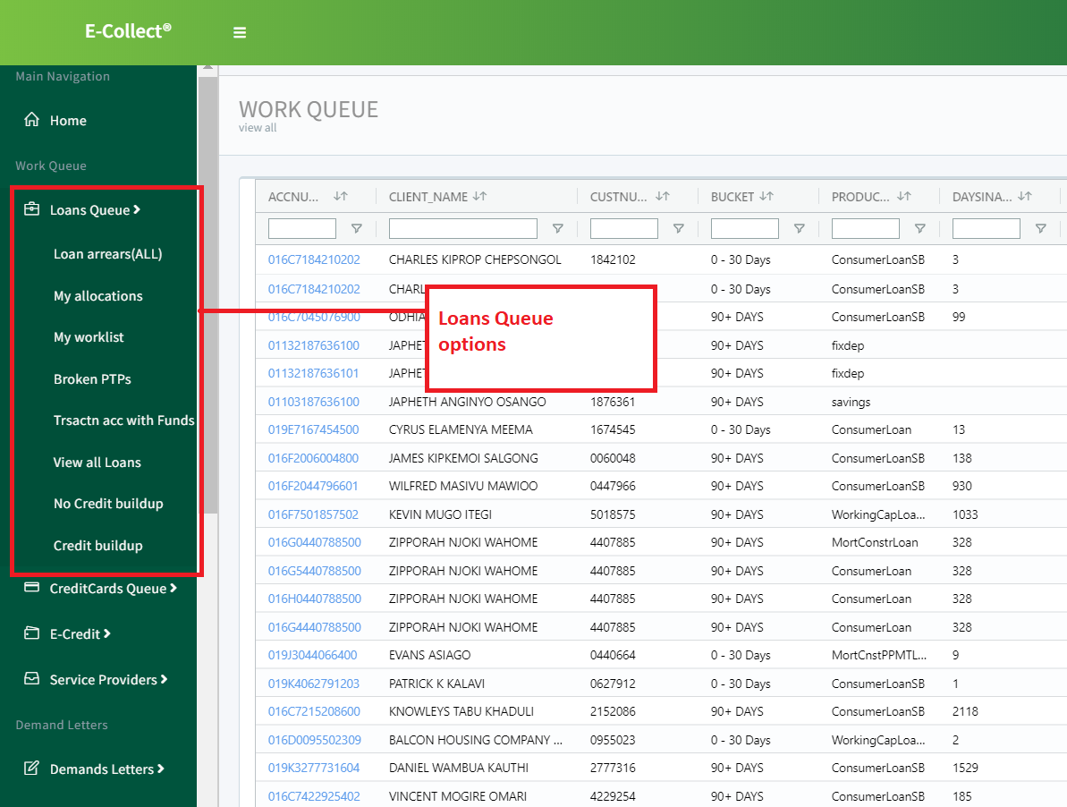accounts with funds, all loans, credit build up and no credit build up.

These are all the loan accounts available on e-collect. Here a collector can search, filter, view, action accounts.

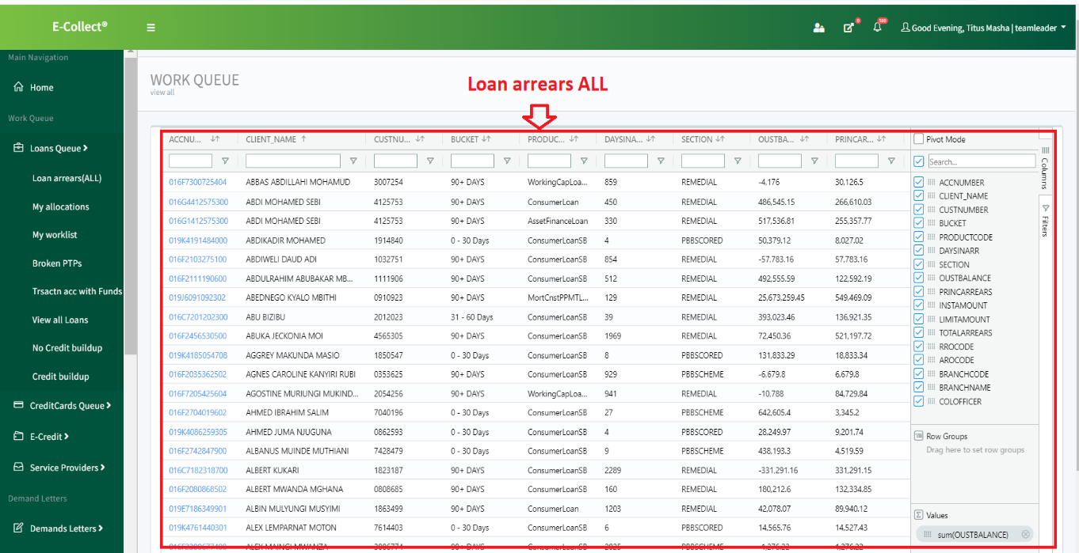

## 2.4 Broken promises

This lists all the accounts that have not fulfilled their Promises to pay. If an account promises to pay Ksh 500 but pays Ksh 100 then that account will be listed under Broken PTPs since it has not fulfilled the agreed amount.

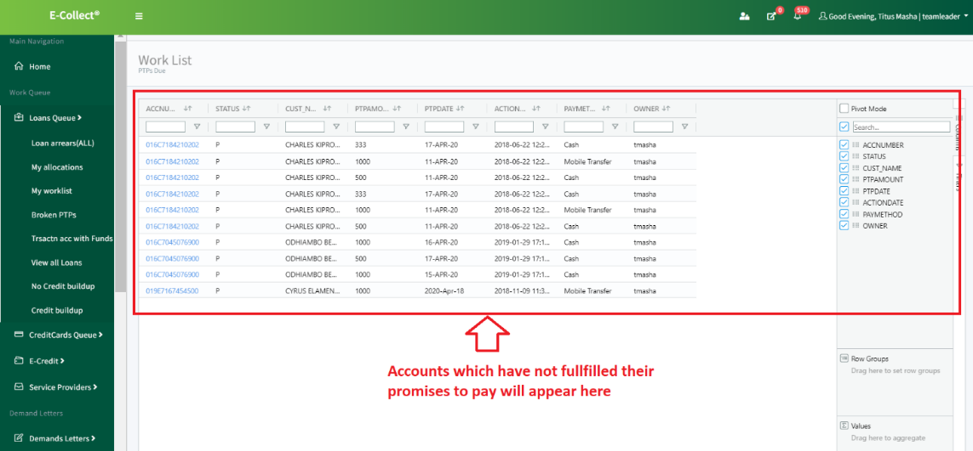

## 2.5 E-Credit

These are the e-credit loans that are offered by Co-operative bank to their customers. These loans can be accessed through mobile devices and once a request has been accepted, the customer is able to be credited with the loan.

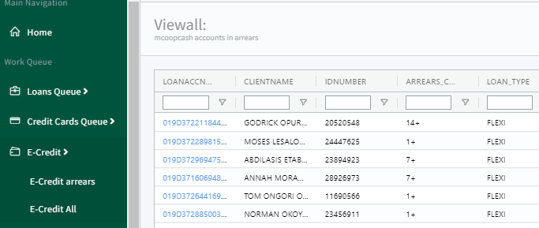

## 2.6 Service Providers

These are external services that are procured by the bank to enable the efficient collection of debt. These include, EDC, Insurers, Yards, Auctioneers, Marketors, Valuers, Repossesors.

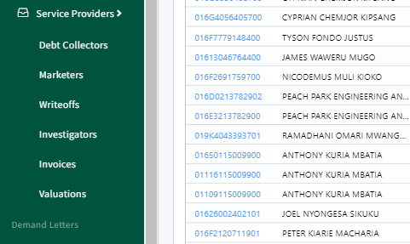

# Collector activity

## 3.1 Change in actioning an account

Due to the new upgrade and as per our client request, we have changed the actioning page.

Steps in actioning an account:

* + 1. Log into the system; this should display the dash board.
    2. Click on any account number that you are interested. Account numbers are in blue color.

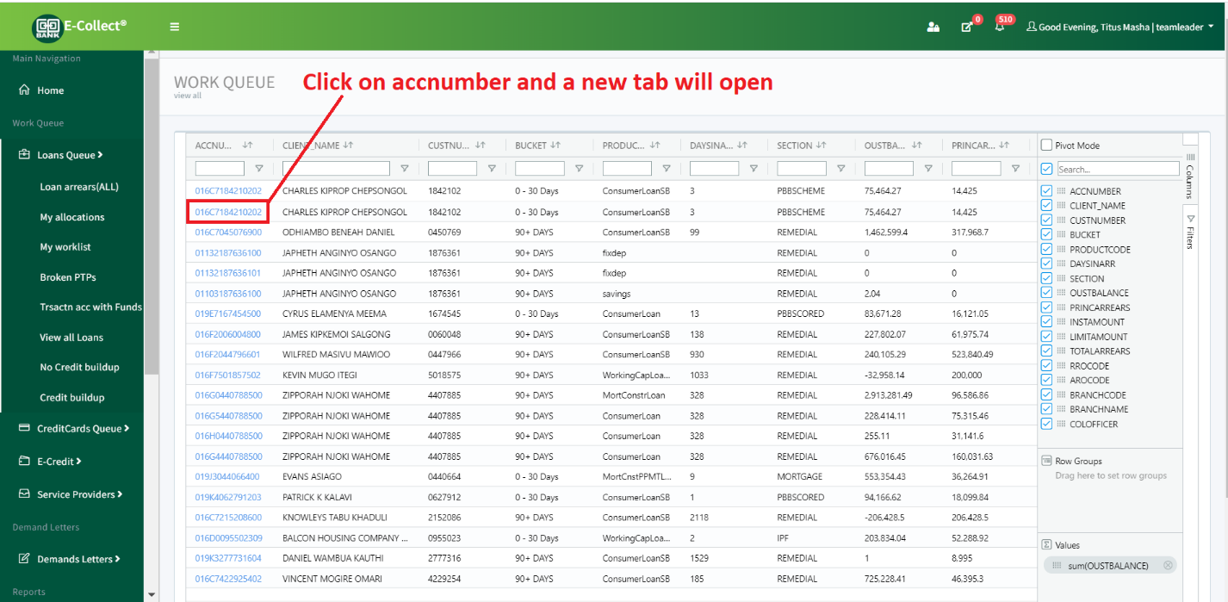

* + 1. A new tab will open. This tab will contain customer details as well as tabs that are responsible for actioning an account.

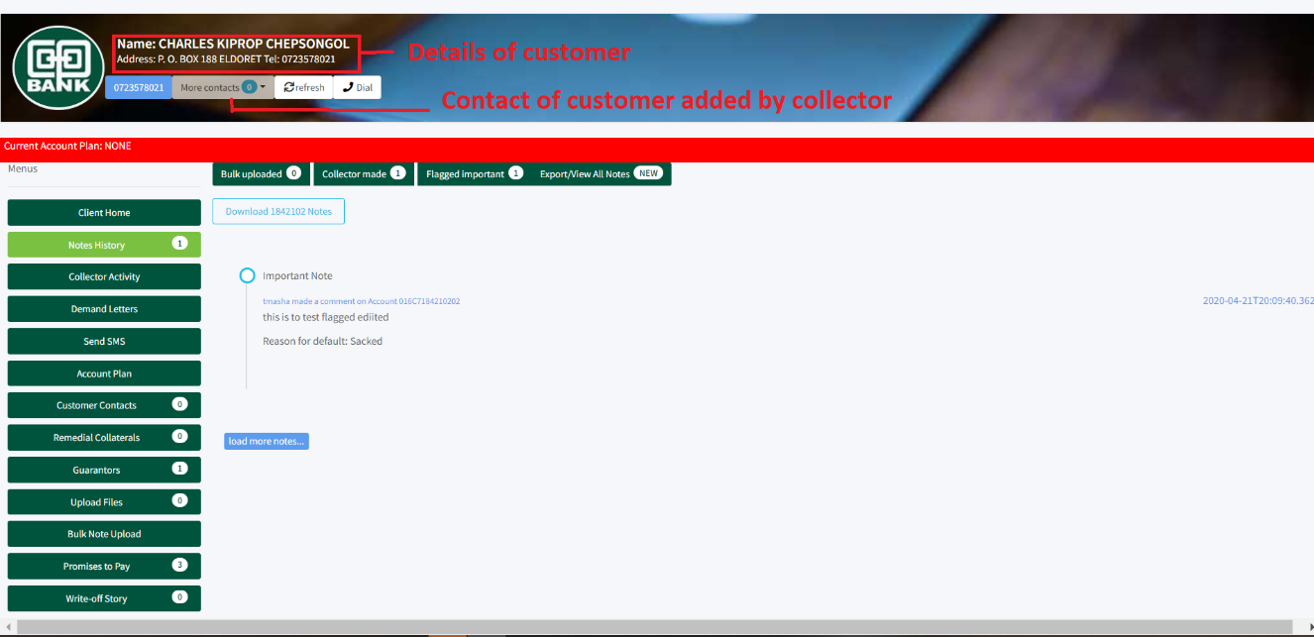

* + 1. The top part of the screen contains the customer details. These details are as per the information that is available from the database.
    2. The left part contains a sidebar with options. This includes:

## 3.2 Collector activity sections

### 3.2.1 Client Home

Here the collector can view the account balance of the customer, how many accounts are in his or her ID number, Credit Card if any, also if he or she is a director of a company.

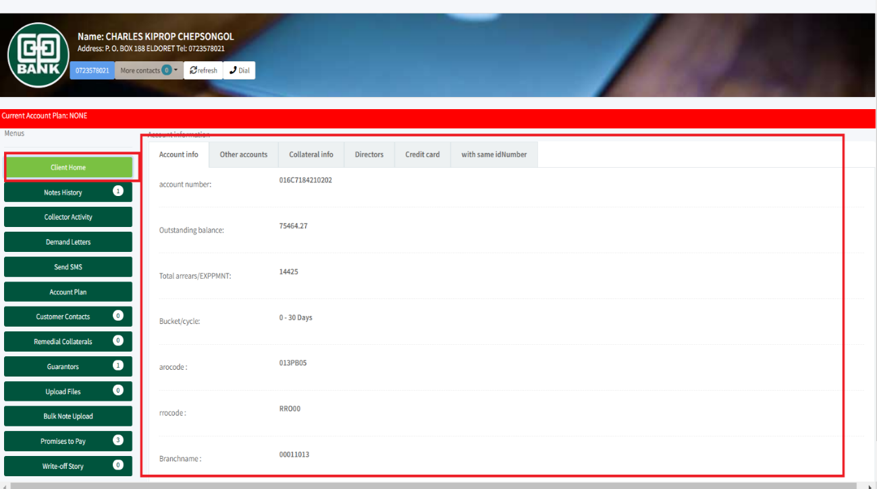

### 3.2.2 Notes History

This is where all the notes ever captured about the account can be found. The notes are listed starting 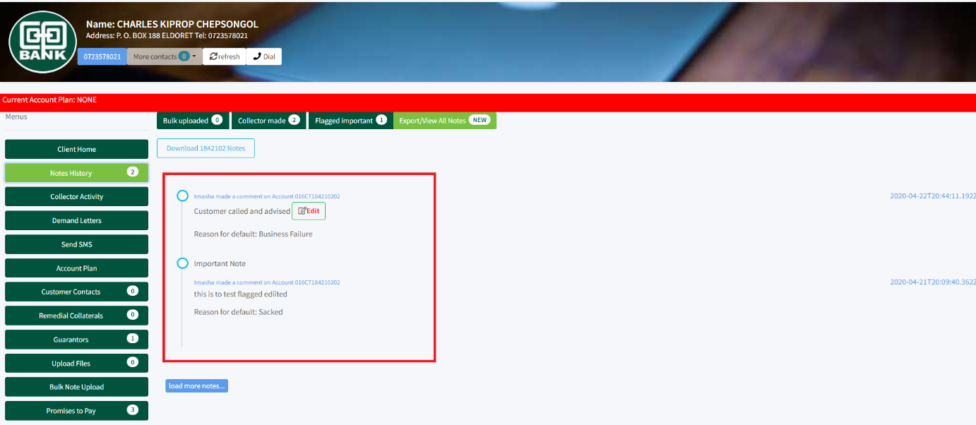with the latest to the oldest.

N/B: You can edit a newly created note. This can be done on same day. Otherwise the edit button will disappear. The collector can also see how many notes that are available, and can also download the notes.

### 3.2.3 Collector activity

Here is where the collectors the action they have taken on the account. The options are built on the go. This means that options will be available depending on what the collector has selected.

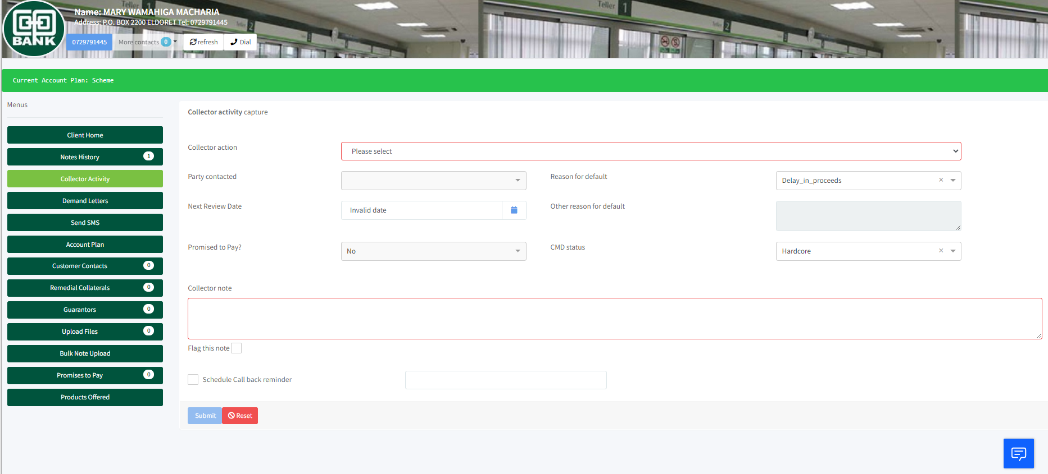

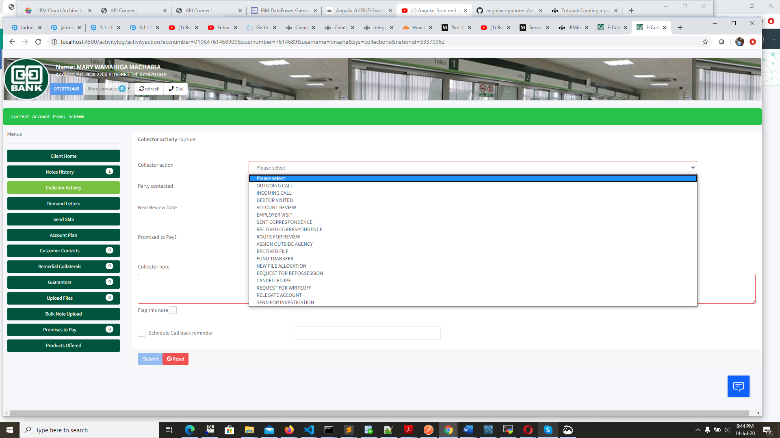

### 3.2.4 Demand letters

To issue a demand letter

1. Click **Demands** on the collector activity page.

The demands page opens

1. Select **Demand type**.
2. Confirm/input **customer email** field.

Optionally you may preview the demand letter. Click **Generate & send**

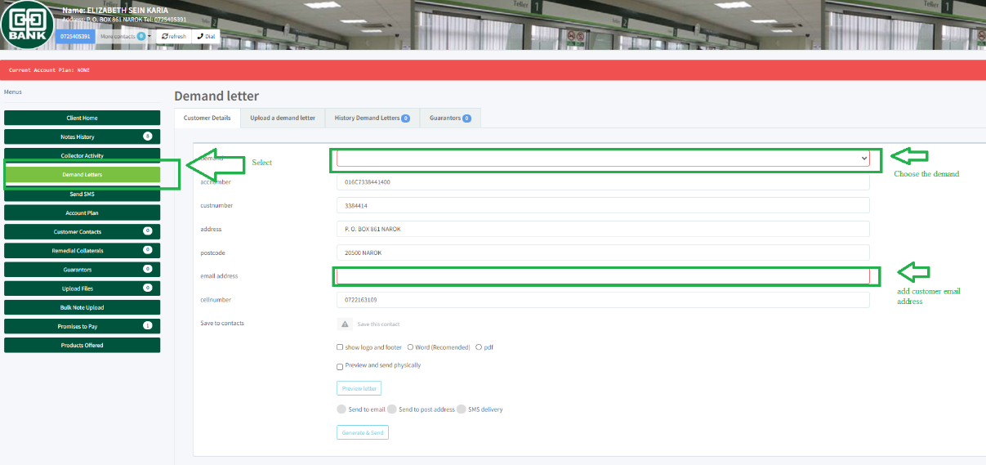

3.2.5 SMS

The system can send SMS alerts to customers automatically and manually.

1. Automatic sending of SMS messages:

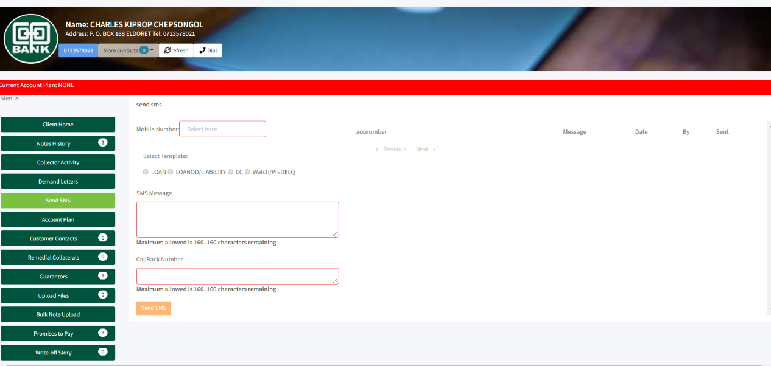The system automatically sends out messages for Personal Loan Scored loans that are 7+ days in arrears and flexi loans that are 1+ days in arrears.

1. The user can manually send out a sms to a customer. The sms message for collections department cannot be edited

Here the collector can manually send an SMS to the customer using the pre-defined templates. The templates are made by the team leaders.

### 3.2.6 Account Plan

Collector has the ability to select account plans and assign to the account. The account plans are made by team leaders and therefore collectors can only select the available account plans. If an account has no account plan, there will be a red strip indicating it doesn’t. Otherwise if it has been assigned an account plan, the strip will turn to green and will have the name of the account plan.

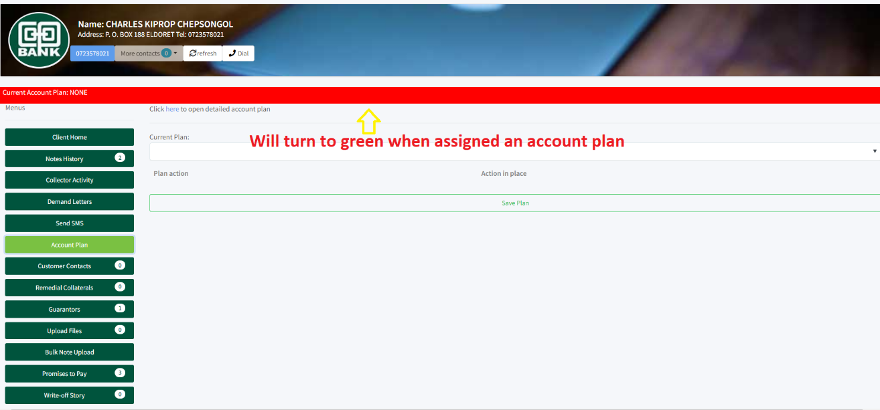

### 3.2.7 Customer contacts

Here the collector, after having a conversation with the customer or the customer visiting the branch, they can manually add contacts. This contact will be available to the account. After adding a contact, the collector should press refresh button to see the newly added contact.

### 3.2.8 Remedial Collaterals

Here the collector can view the available collaterals that this account has put. Moreover, the collector can add new collaterals to the account.

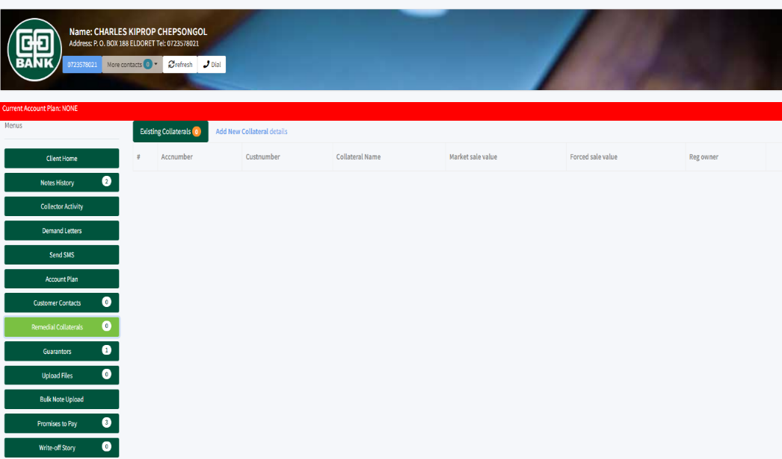

### 3.2.9 Guarantors

Here the collector can view the already existing guarantors as well as add new guarantors.

### 3.2.10 Upload files

Here the collector has the capability of uploading files relevant to this account. These files are documents only, meaning they should be in a document format. The collector can also view and download already available documents about the customer.

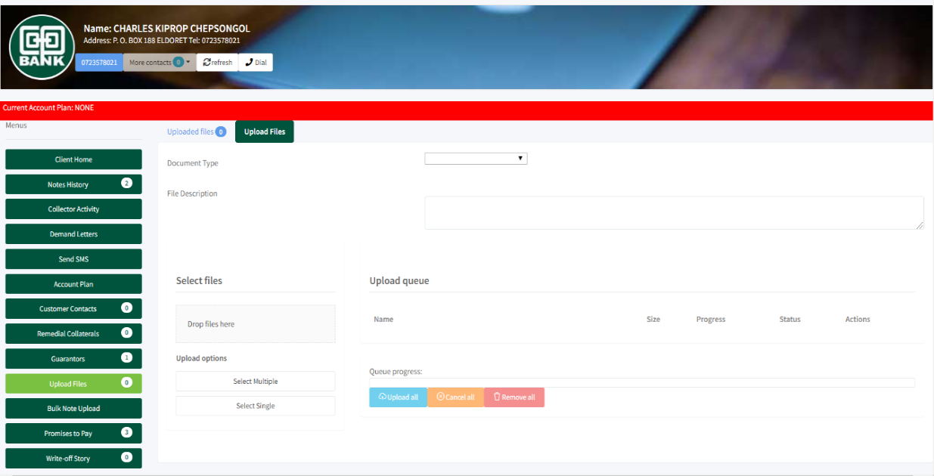

### 3.2.11 Bulk Uploads

In this section, you can upload collector notes from an excel file. An excel template with the required format is provided and can be downloaded to be used

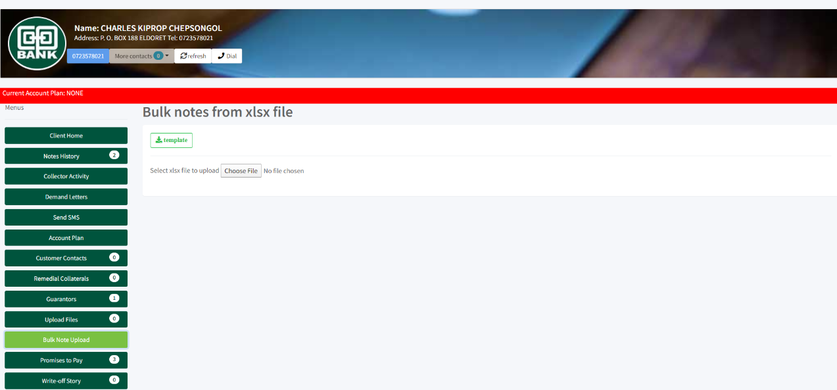

### 3.2.12 Promises to Pay

Here the collector can view the history of PTPs that the customer has ever given.

# 4.0 Service providers

## 4.1 Cancellation of Insurance Premium Finance

IPF cancellations has the below flow:

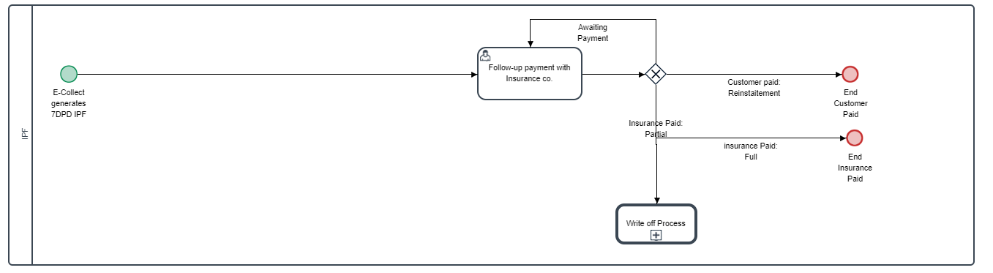

On 7DPD E-Collect pulls out and queues the accounts due for cancellation. IPF officer follows the following steps

1) Under **Asset Finance & IPF** menu click **IPF**

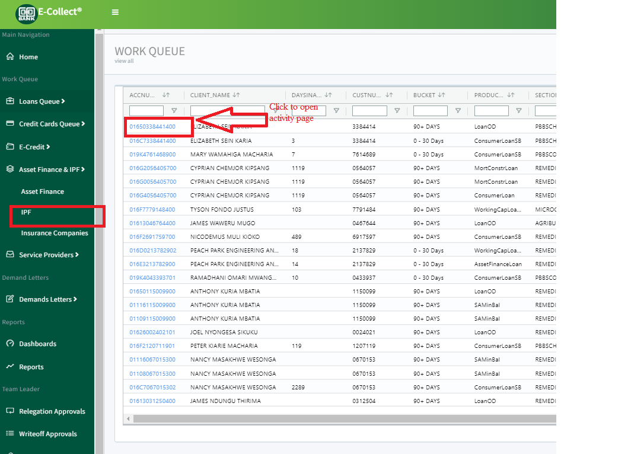

2) On the activity page, select **Cancel IPF** under collector actions, then click **Link to cancel IPF**. IPF Cancellation details page opens.

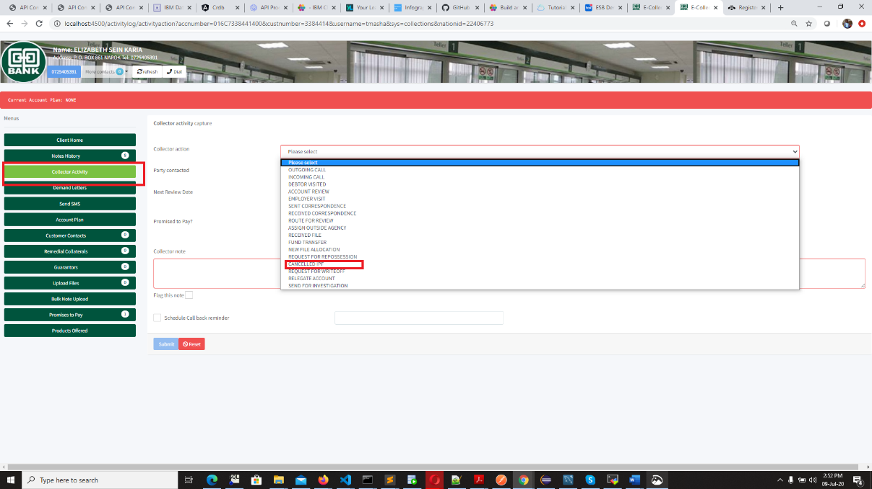

3) Fill out the details in the IPF cancellation page and **Submit**. You may optionally choose to preview the cancellation letter by clicking the **preview button**

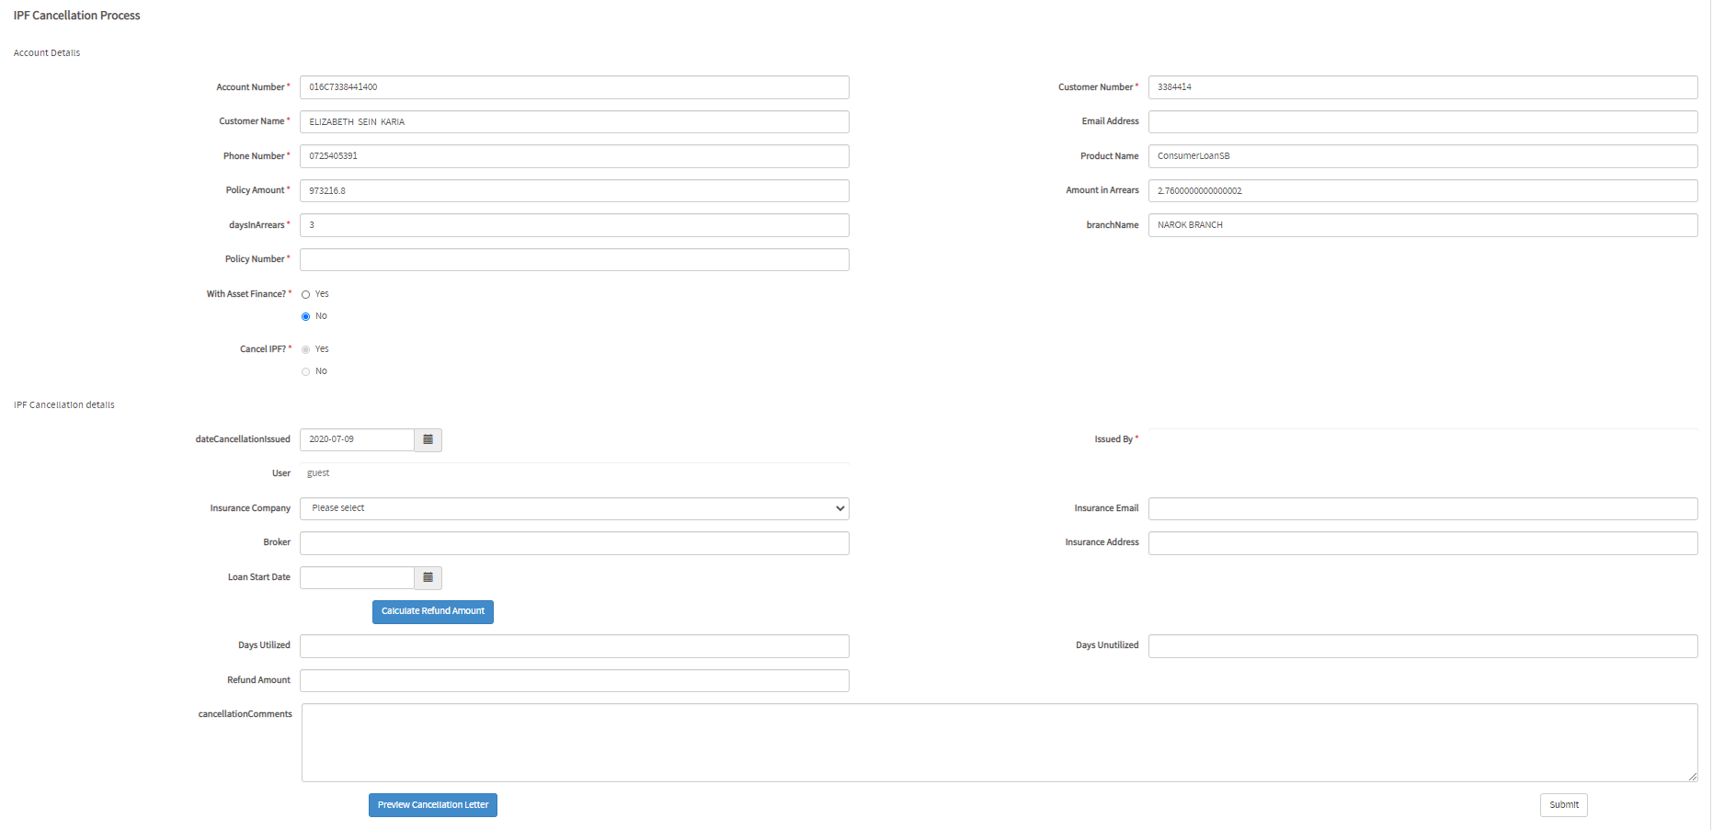

## 4.2 Repossession order

### 4.2.1 Request for repossession

This section describes how you issue repossession instruction to one or more auctioneers. Below is the process flow

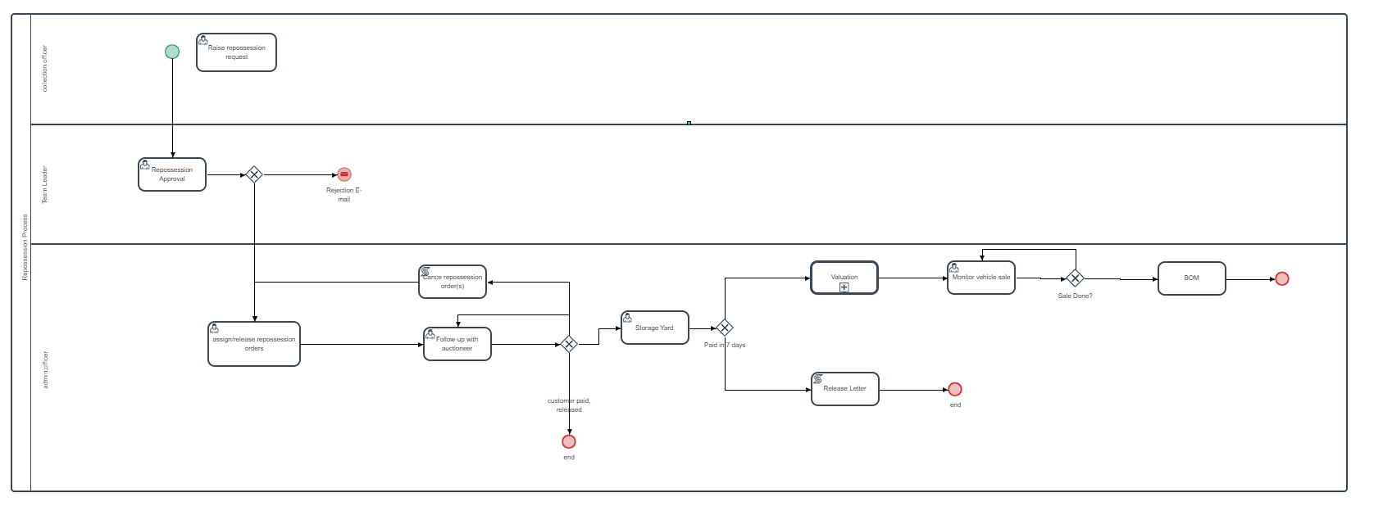

The process is as follows:

1. Under **Asset Finance & IPF** menu click **Asset Finance.** A list of accounts which are due for repossession will show on the right panel. Select the account you intend to request for repossession and click on the **account number** field.
2. On the activity page, select **Request for repossession** under collector actions, then click **Issue repossession order**. On a separate tab, repossession request form opens. This needs to be fully filled.

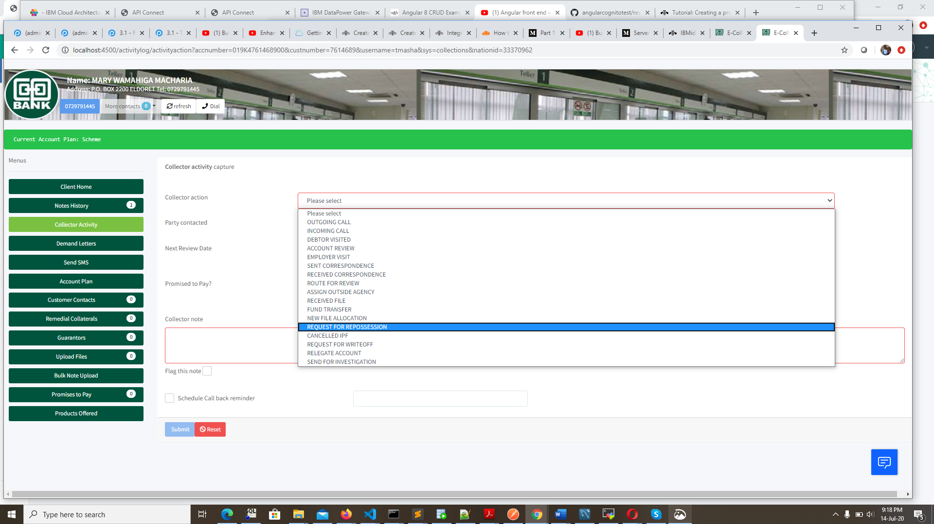

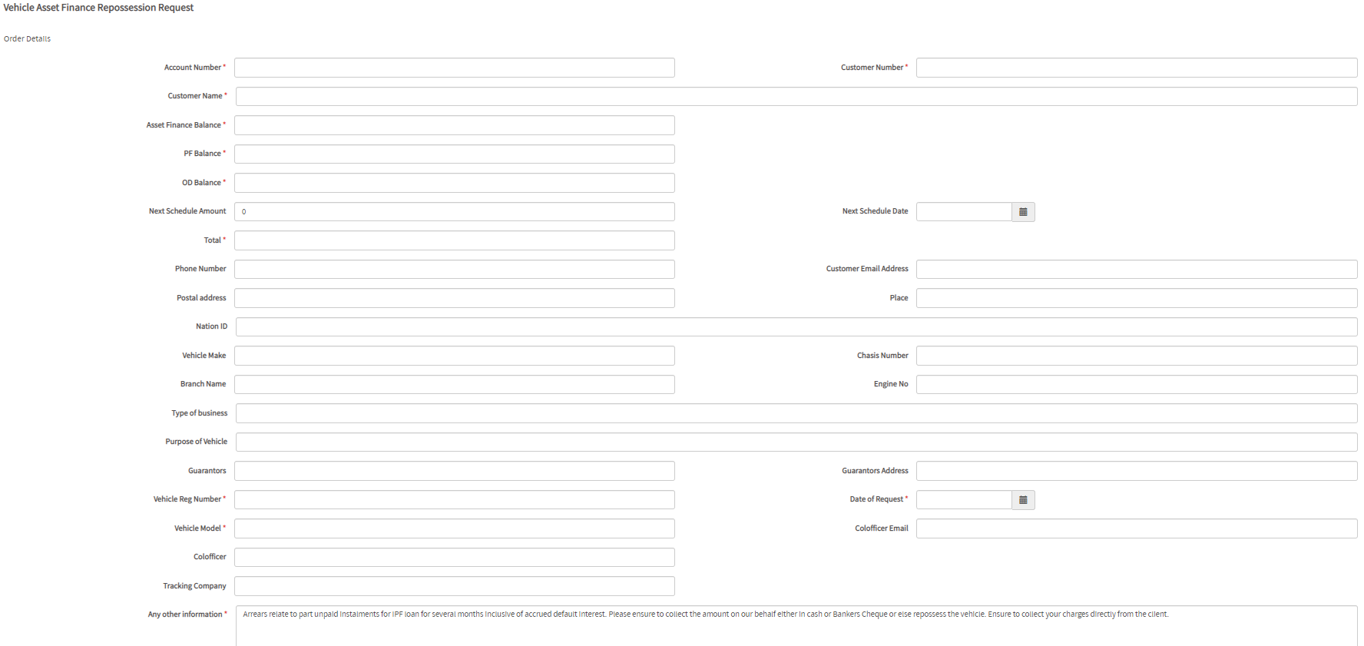

### 4.2.2 Repossession approval

Team leader approves the repossession request before it is assigned and released. The following steps are followed

Click on **workflow** from the home page. Workflow login page appears. Login with your active directory credentials

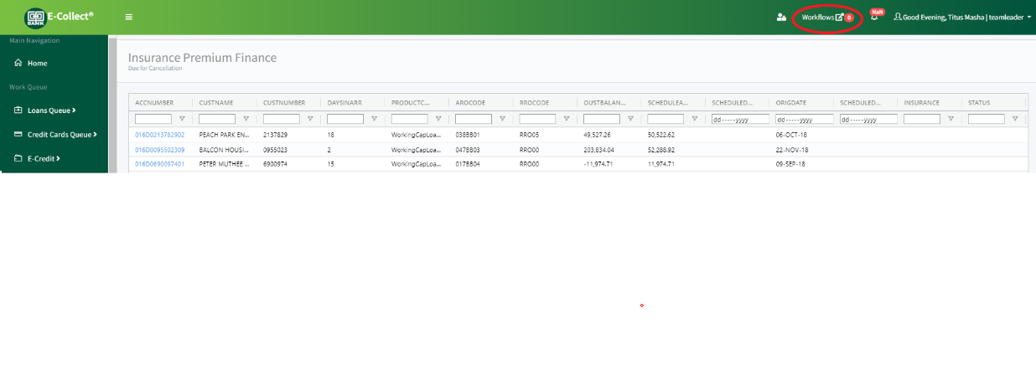

On **inbox** click on the case, then either approve or decline. A decline will trigger an email to the requesting officer and the case ends.

An **approval**, the case moves to a repossession admin officer for assignment and instruction release



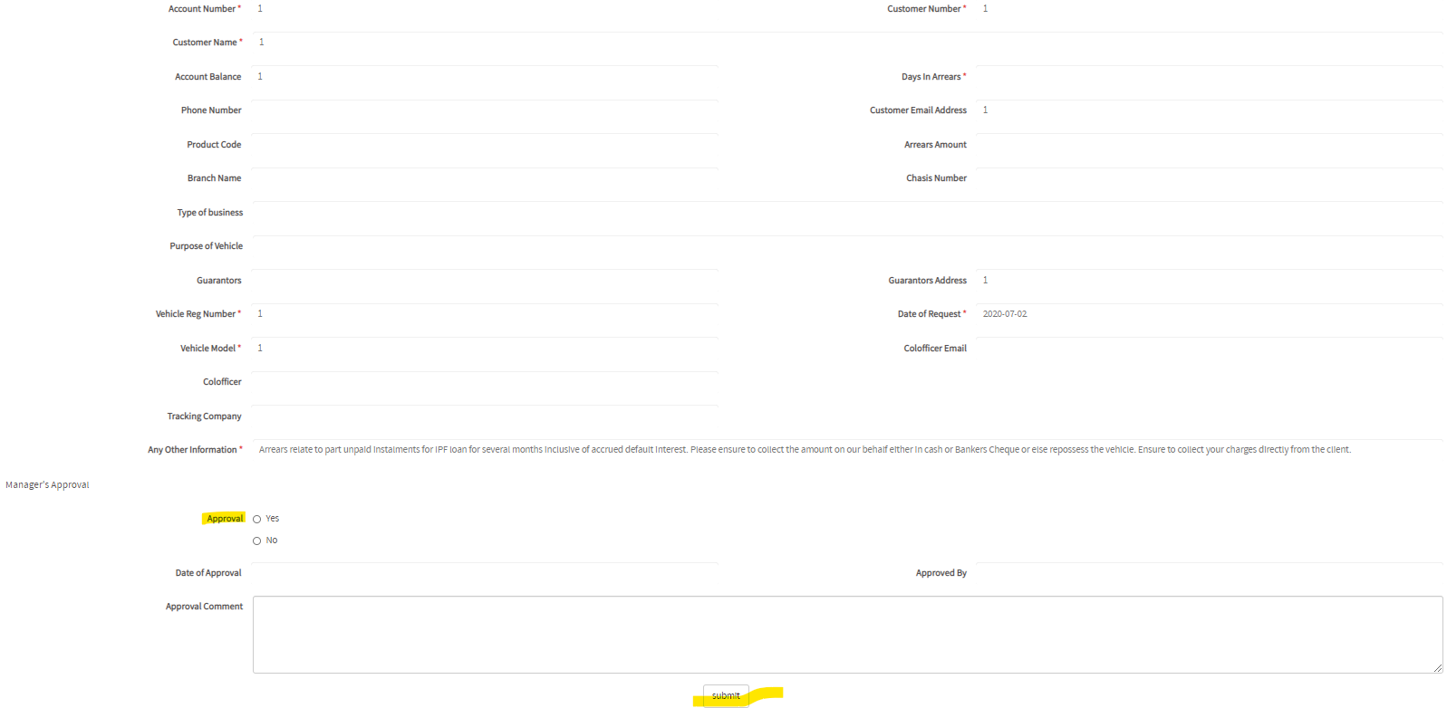

### 4.2.3 Instruction release

Remedial officer in charge of repossession assigns an auctioneer and releases the instruction

### 4.2.4 Auctioneer follow-up

Remedial officer follows up with the Auctioneer on the progress of repossession

### 4.2.5 Storage yard

On repossession, storage booking form is recorded

### 4.2.6 Valuation

E-Collect shall trigger valuation 14 days after repossession. User can optionally send an account for valuation by following the following steps

### 4.2.7 Marketing

Once valuation process is complete, Vehicle process moves to marketing and sales

## 4.3 Investigations

One can recommend an account for investigation, providing the reason for investigation. This request goes to remedial admin officer who will assign an external investigator to carry out the investigation.

Here below is the process flow

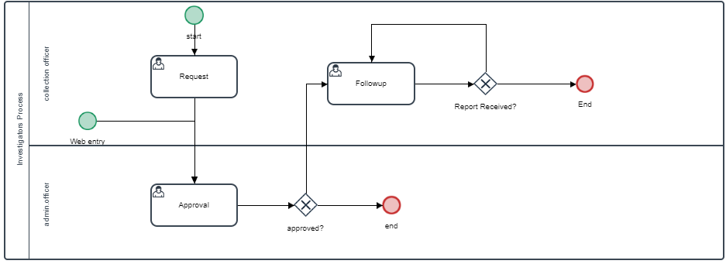

### 4.3.1 Request for investigation

Any user can send an account for investigation

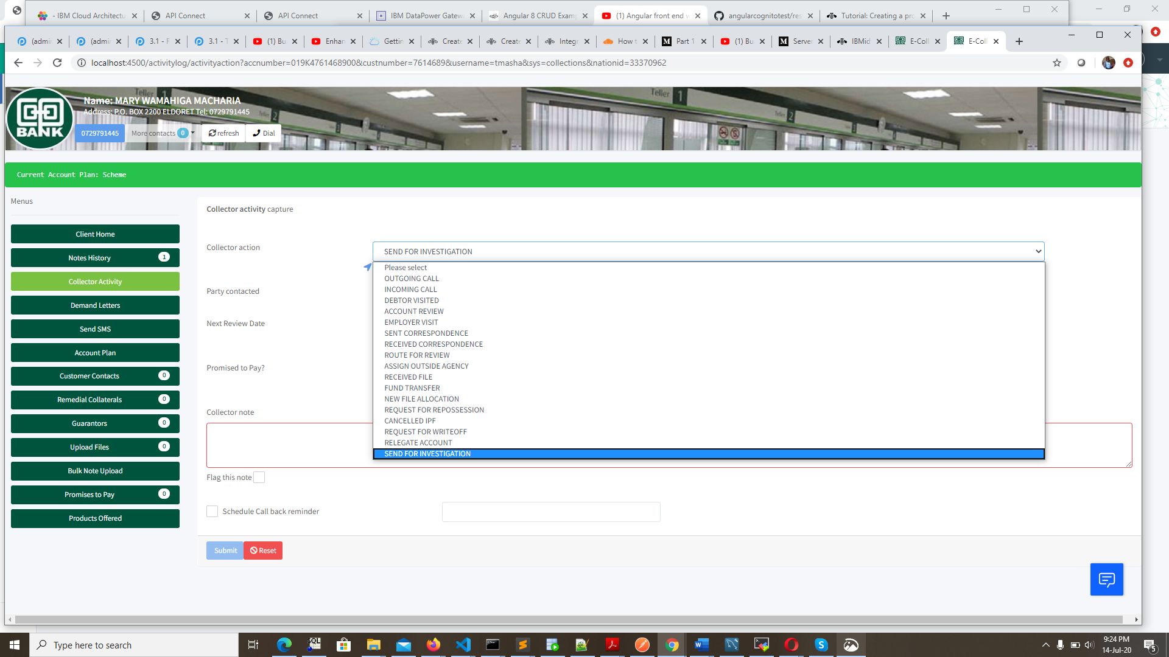

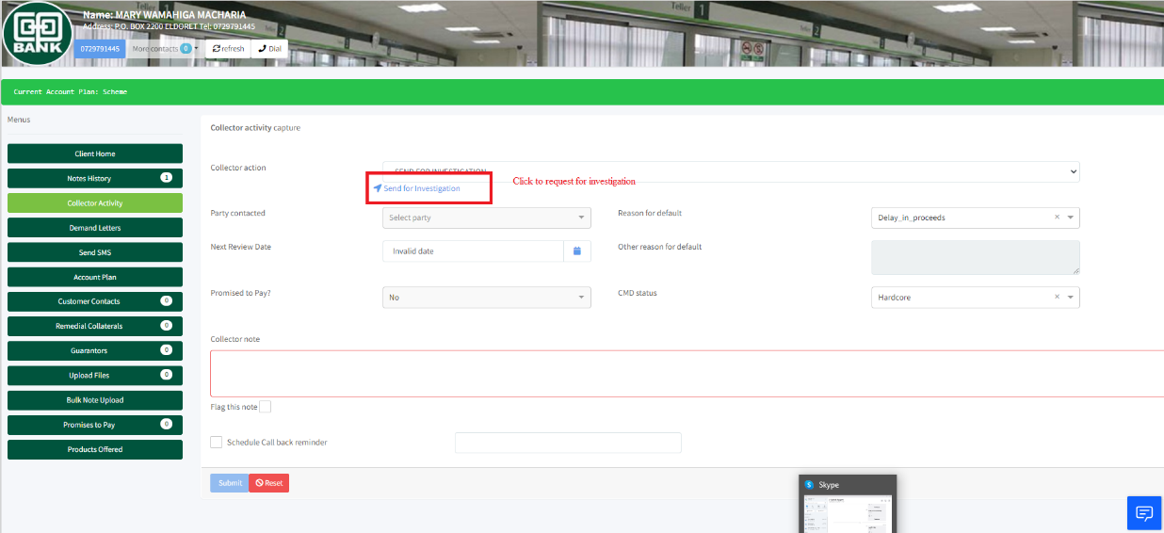

Investigation request form

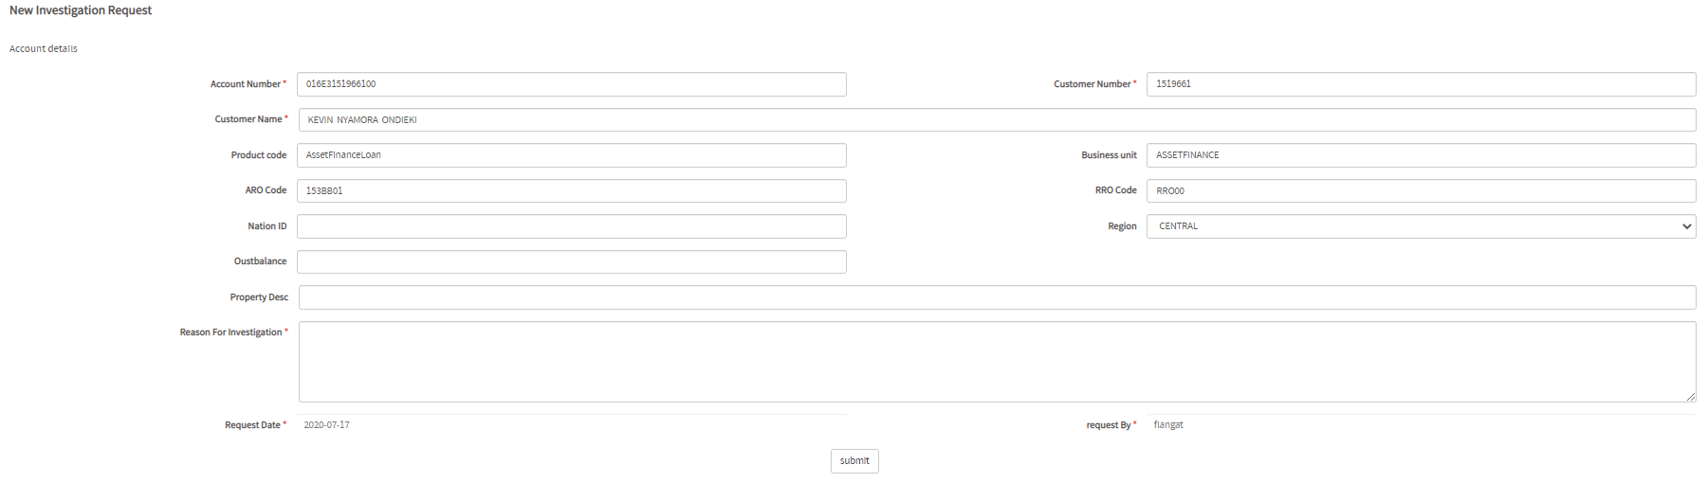

On submit the case will be routed to remedial admin officer for investigator assignment and release the instructions

### 4.3.2 Assign & release for investigation

Remedial admin officer will assign an investigator to a request for investigation and release the instructions. The following steps are followed:

Click on **workflow** from the home page. Workflow login page appears. Login with your active directory credentials



Under **inbox** click on the case, either approve or decline this instruction. On decline the case stops.

On approval, assign an investigator. You may optionally preview **investigation instruction letter,** then click **submit** to release the instruction.

The instruction will be sent on email, to the investigator

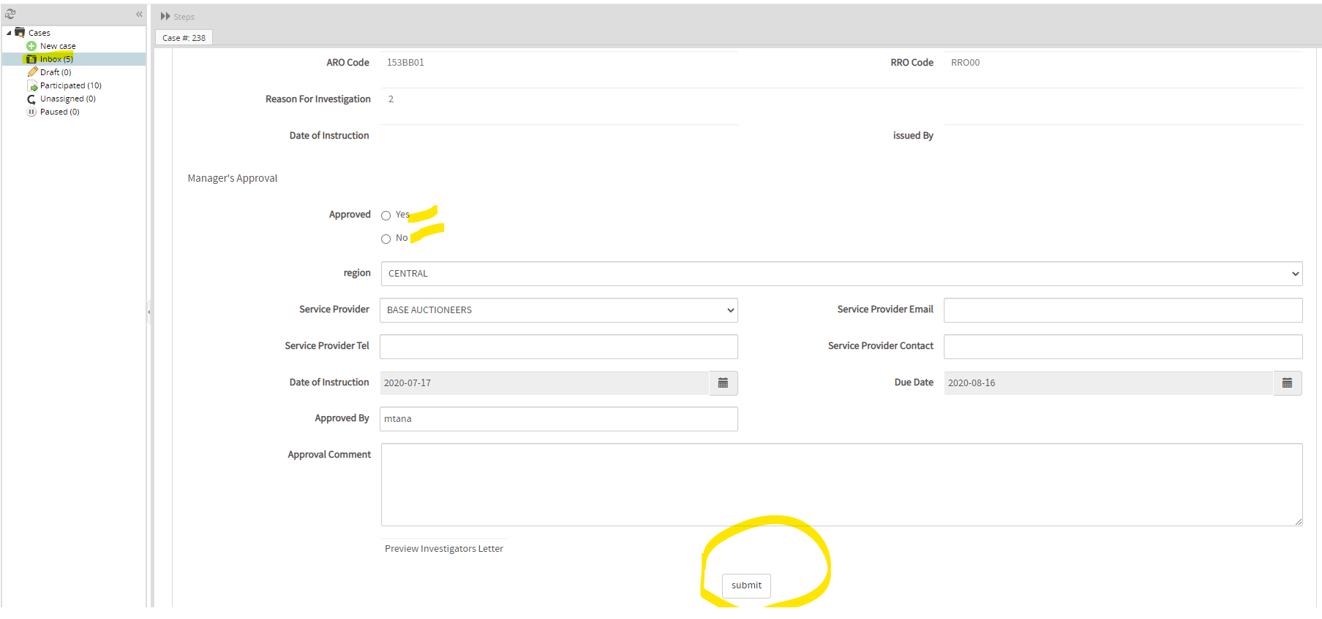

## 4.4 External debt collectors

Assigning an account to an external debt collector follows the following steps

### 4.4.1 New request for external debt collection

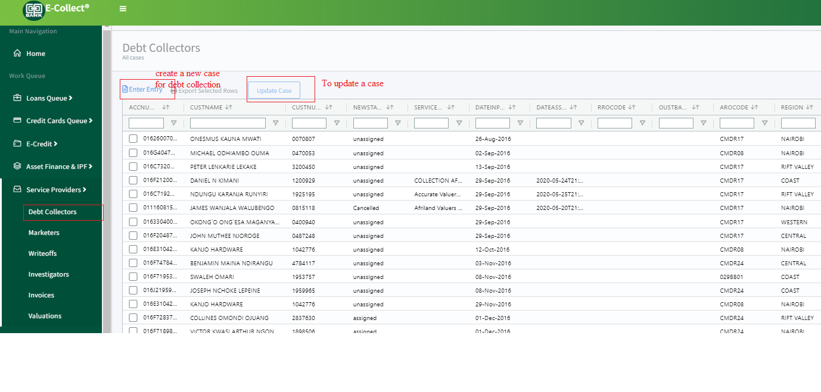

### 4.4.2 Update external debt collector case

## 4.5 Write-offs

Write-off process is as follows

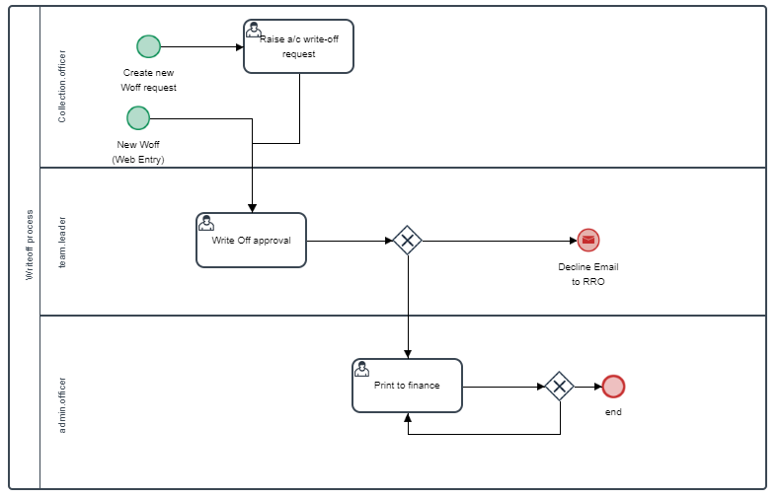

### 4.5.1 Recommend for write-off

A relationship officer or a collection officer may request for a write-off. The following steps are followed to initiate such requests

Select **request for writeoff** from the activity page

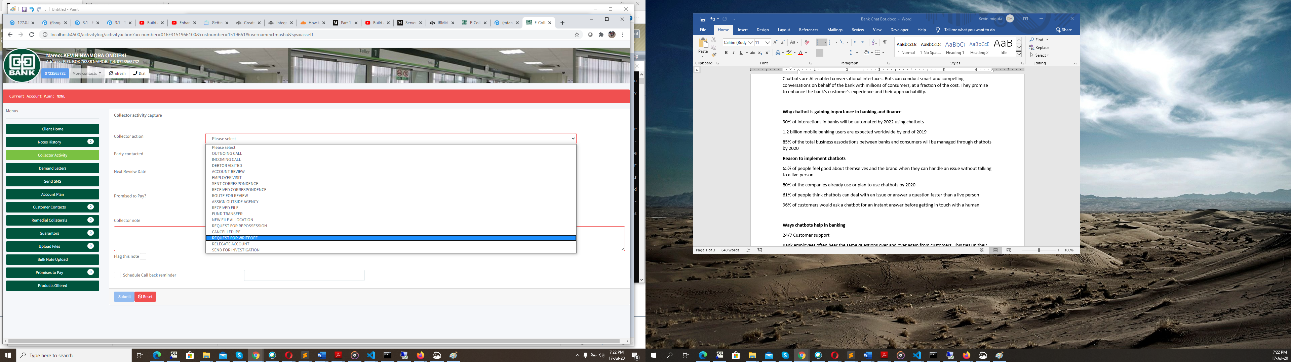

Fill up repossession details on the pop-up page, on click of **link to request write off**

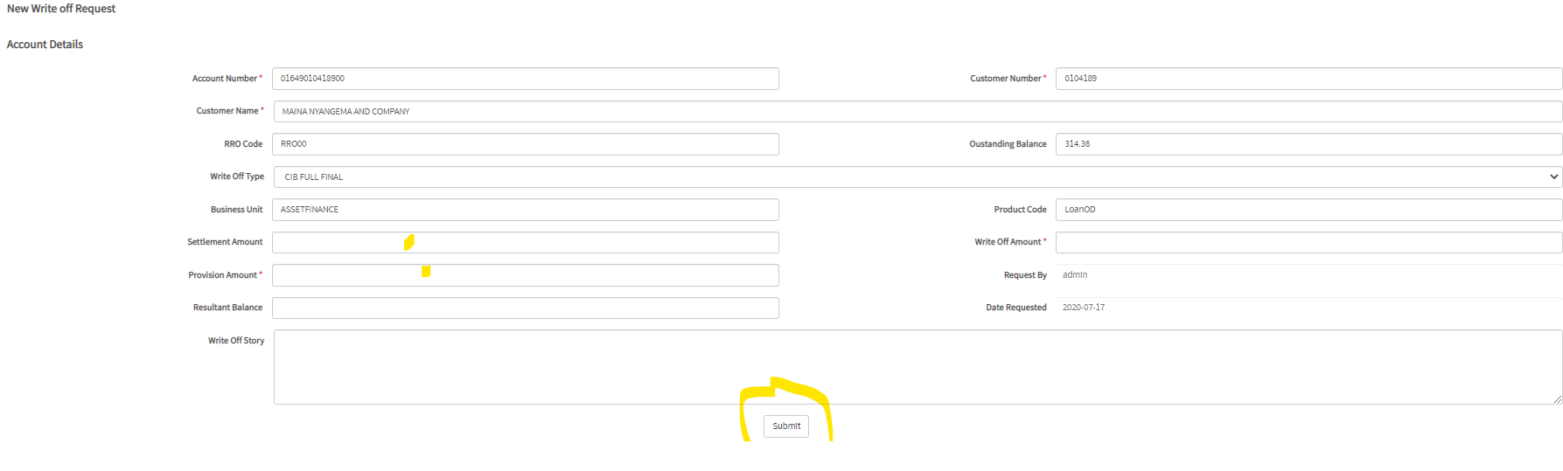

Click **submit**

The instruction goes to a remedial officer in charge of write-off

### 4.5.2 Process write-offs

Admin officer in-charge of relegation approves and processes write offs. The following steps are followed:

Log into E-Collect and from the home page, open up **service provider** menu and click **Writeoffs**

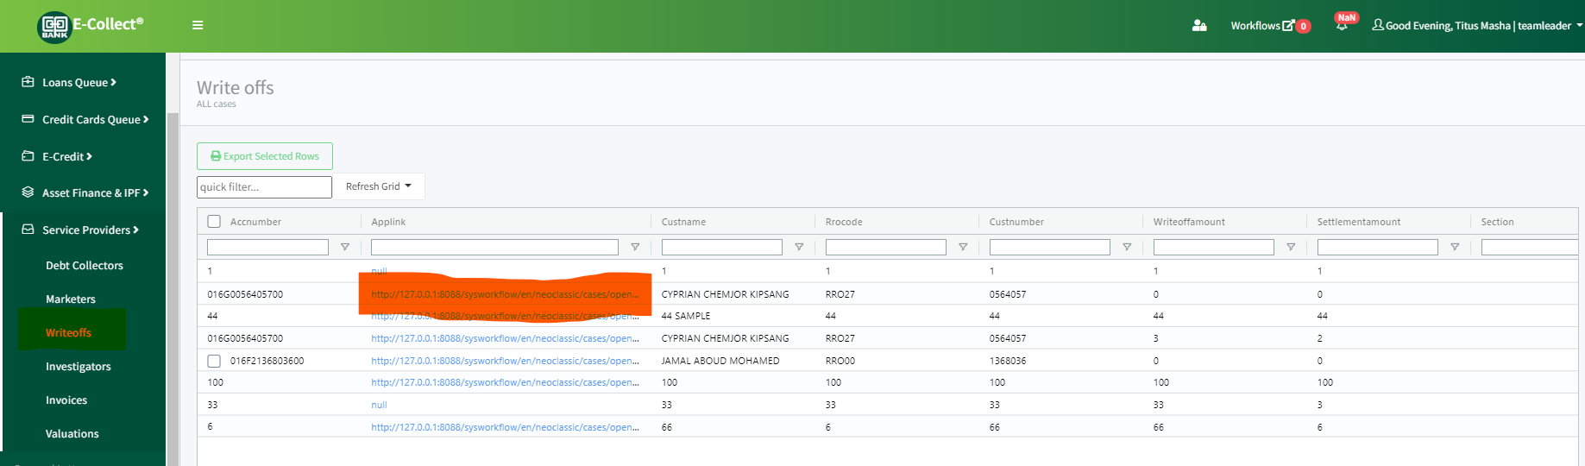

Grid shows all writeoff requests.

Click on the **Applink** to open the case, approve or decline. Once approved you can export the case(s) to excel for further offline processing to finance

## 4.6 Invoices

Below is the process flow for service provider invoices

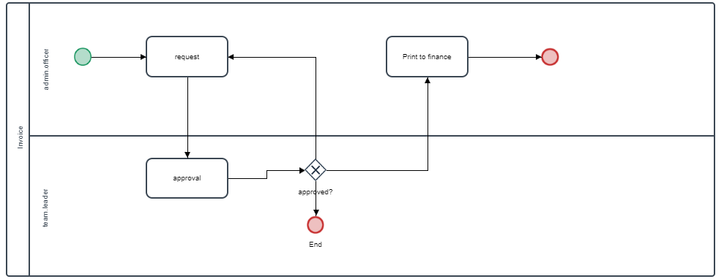

### 4.6.1 New invoice

Relegation admin officer in-charge of invoices, enters the invoice details. The following steps are followed:

Access **invoice** menu from E-Collect home page. Click **Enter new invoice note.**

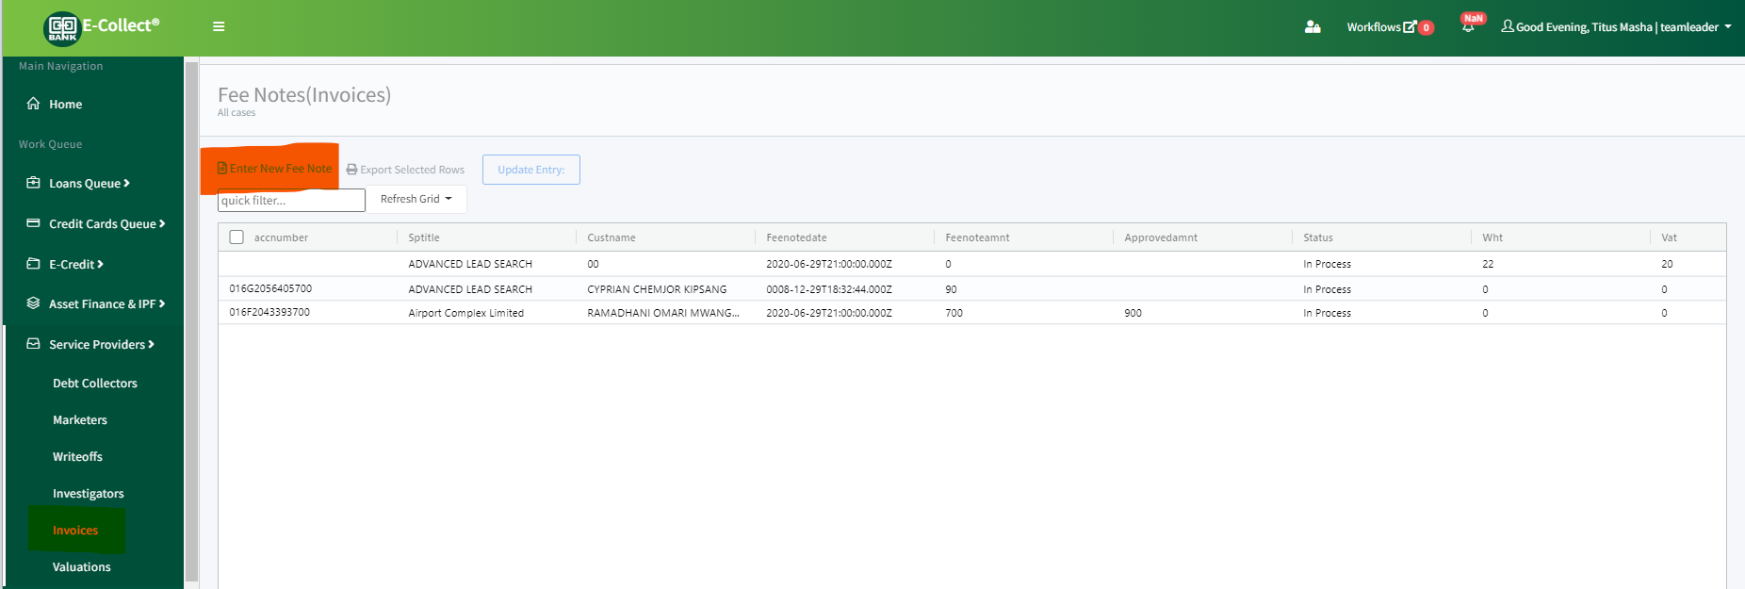

Fill up the details in the resultant form

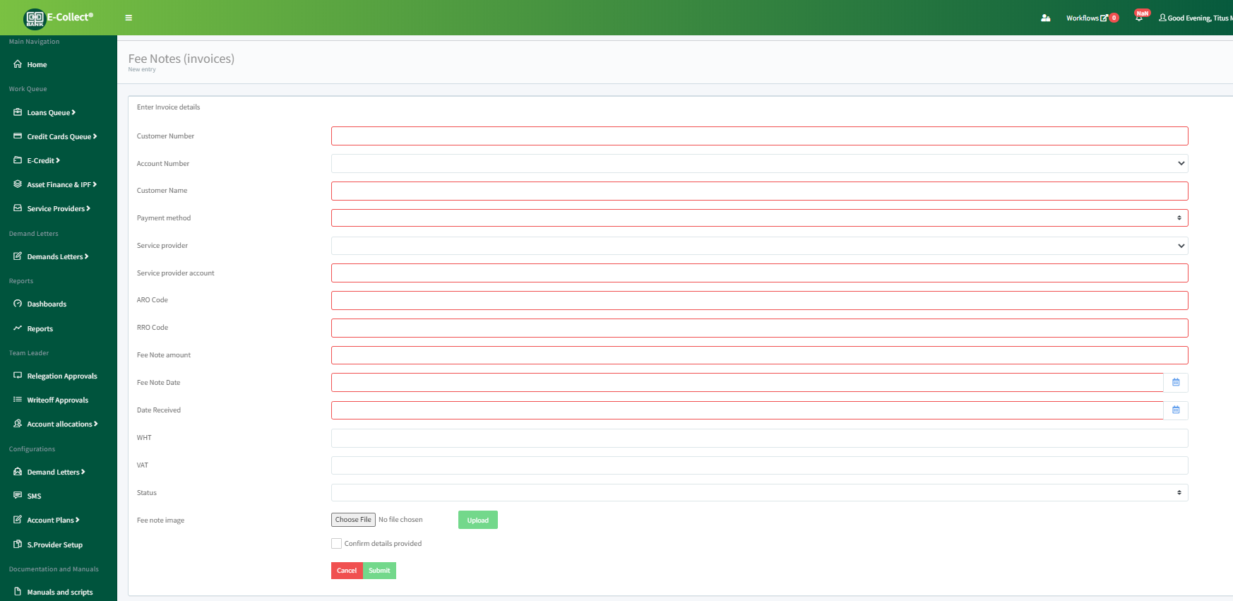

Click on **submit** to save the invoice details

### 4.6.2 Print invoice

Approved invoices are printed for payment to finance. Select the cases to print/process to finance by selecting the **check box** next to the case and click on **Export selected rows**

Ones exported, the cases will disappear from the list of invoices

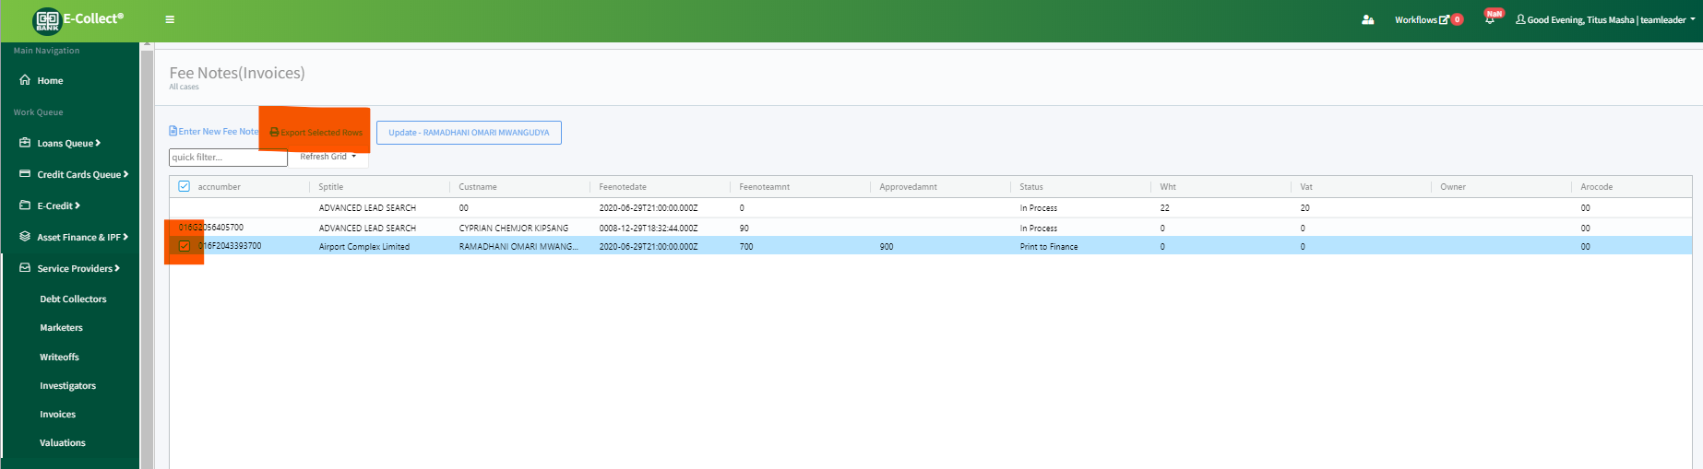

# 5.0 REPORTS

In this section, we describe the various user reports and how to access these reports. The following steps are followed when you need to access and open a report

1. Click **Reports**.

The Reports page opens.

1. Click **Report Name**.
2. Specify the **Report parameters** field.

The report will open on a separate tab

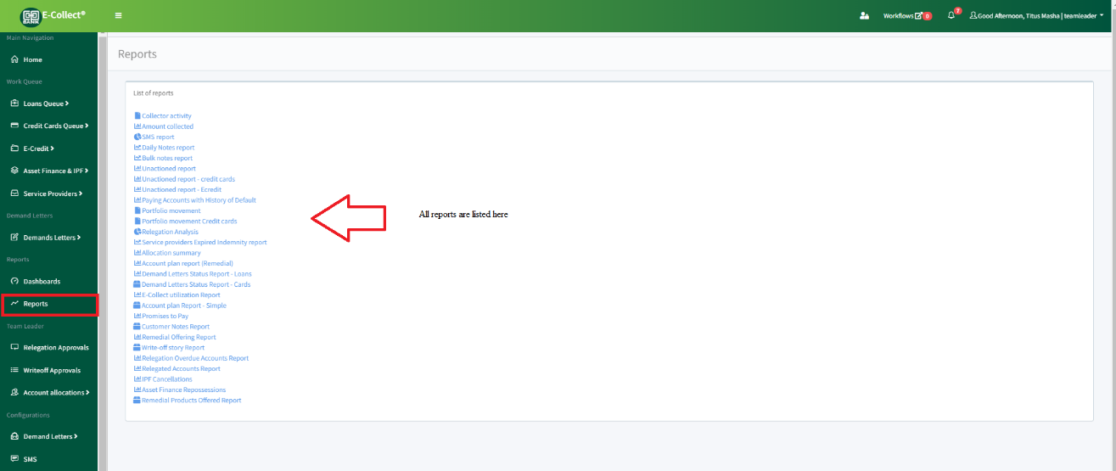

# 6.0 System Administration

This section describes the activities carried out by the IT Support. These include

1. User management
2. Platform metrics
3. Microservices
4. Troubleshooting

## 6.1 User management

This section describes how to add and edit user details on E-Collect. The user MUST already be existing on Active directory. The AD credentials are used to login into the system

Steps:

IT Support admin access the admin page below. Under users, search with the username

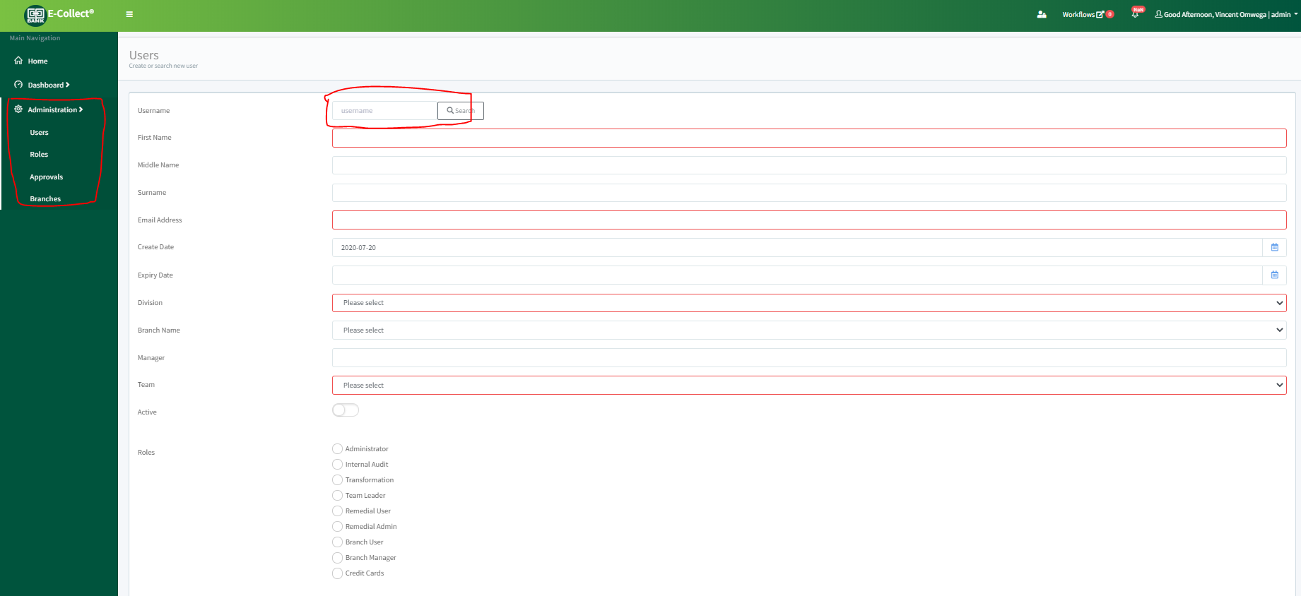

Fill the details for a new user or update user details including appropriate roles and click **submit**.

## 6.2 Platform metrics

Platform metrics are captured by Prometheus and displayed in charts with Grafana. You can access these charts from

Admin Page > Dashboards > Performance Metrics

## 6.3 Microservices

E-Collect is built on microservices running on containers. Its decoupled in modules performing specific tasks. These modules are packaged as docker images running on Kubernetes

Below is the architecture overview

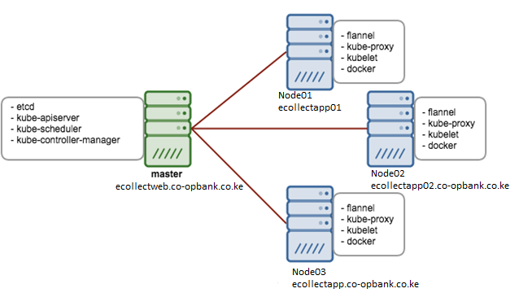

The Master Node is the most vital component which is responsible for the management of Kubernetes cluster. It is the entry point of all kinds of administrative tasks. The master node has various components:

* **API Server** – It provides kubernetes API using Jason / Yaml over http, states of API objects are stored in etcd
* **Scheduler –** It is a program on master node which performs the scheduling tasks like launching containers in worker nodes based on resource availability
* **Controller Manager** – Main Job of Controller manager is to monitor replication controllers and create pods to maintain desired state.
* **etcd** – It is a Key value pair data base. It stores configuration data of cluster and cluster state.
* **Kubectl utility** – It is a command line utility which connects to API Server on port 6443. It is used by administrators to create pods, services etc.

On Worker Nodes following components will be installed

* **Kubelet** – It is an agent which runs on every worker node, it connects to docker and takes care of creating, starting, deleting containers.
* **Kube-Proxy** – It routes the traffic to appropriate containers based on ip address and port number of the incoming request. In other words, we can say it is used for port translation.
* **Pod** – Pod can be defined as a multi-tier or group of containers that are deployed on a single worker node or docker host.

## 6.4 Troubleshooting

The following guide is to help users debug E-Collect running on Kubernetes

Diagnosing the problem

The first step in troubleshooting is triage. What is the problem? Is it your pods, replication controller or your service?

* Debugging pods
* Debugging replication controllers
* Debugging services

### 6.4.1 Debugging Pods

The first step in debugging a Pod is taking a look at it. Check the current state of the Pod and recent events with the following command:

kubectl describe pods **${**POD_NAME**}**

Look at the state of the containers in the pod. Are they all Running? Have there been recent restarts?

Continue debugging depending on the state of the pods.

#### **My pod stays pending**

If a Pod is stuck in Pending it means that it cannot be scheduled onto a node. Generally, this is because there are insufficient resources of one type or another that prevent scheduling. Look at the output of the kubectl describe ... command above. There should be messages from the scheduler about why it cannot schedule your pod. Reasons include:

* **You don't have enough resources**: You may have exhausted the supply of CPU or Memory in your cluster, in this case you need to delete Pods, adjust resource requests, or add new nodes to your cluster. See [Compute Resources document](https://kubernetes.io/docs/user-guide/compute-resources/#my-pods-are-pending-with-event-message-failedscheduling) for more information.
* **You are using hostPort**: When you bind a Pod to a hostPort there are a limited number of places that pod can be scheduled. In most cases, hostPort is unnecessary, try using a Service object to expose your Pod. If you do require hostPort then you can only schedule as many Pods as there are nodes in your Kubernetes cluster.

#### **My pod stays waiting**

If a Pod is stuck in the Waiting state, then it has been scheduled to a worker node, but it can't run on that machine. Again, the information from kubectl describe ... should be informative. The most common cause of Waiting pods is a failure to pull the image. There are three things to check:

* Make sure that you have the name of the image correct.
* Have you pushed the image to the repository?
* Run a manual docker pull <image> on your machine to see if the image can be pulled.

#### **My pod is crashing or otherwise unhealthy**

Once your pod has been scheduled, the methods described in [Debug Running Pods](https://kubernetes.io/docs/tasks/debug-application-cluster/debug-running-pod/) are available for debugging.

#### **My pod is running but not doing what I told it to do**

If your pod is not behaving as you expected, it may be that there was an error in your pod description (e.g. mypod.yaml file on your local machine), and that the error was silently ignored when you created the pod. Often a section of the pod description is nested incorrectly, or a key name is typed incorrectly, and so the key is ignored. For example, if you misspelled command as commnd then the pod will be created but will not use the command line you intended it to use.

The first thing to do is to delete your pod and try creating it again with the --validate option. For example, run kubectl apply --validate -f mypod.yaml.

The next thing to check is whether the pod on the apiserver matches the pod you meant to create (e.g. in a yaml file on your local machine). For example, run kubectl get pods/mypod -o yaml > mypod-on-apiserver.yaml and then manually compare the original pod description, mypod.yaml with the one you got back from apiserver, mypod-on-apiserver.yaml. There will typically be some lines on the "apiserver" version that are not on the original version. This is expected. However, if there are lines on the original that are not on the apiserver version, then this may indicate a problem with your pod spec.

### 6.4.2 Debugging Replication Controllers

Replication controllers are fairly straightforward. They can either create Pods or they can't. If they can't create pods, then please refer to the [instructions above](https://kubernetes.io/docs/tasks/debug-application-cluster/debug-application/#debugging-pods) to debug your pods.

You can also use kubectl describe rc ${CONTROLLER_NAME} to introspect events related to the replication controller.

### 6.4.3 Debugging Services

Services provide load balancing across a set of pods. There are several common problems that can make Services not work properly. The following instructions should help debug Service problems.

First, verify that there are endpoints for the service. For every Service object, the apiserver makes an endpoints resource available.

You can view this resource with:

kubectl get endpoints **${**SERVICE_NAME**}**

Make sure that the endpoints match up with the number of containers that you expect to be a member of your service. For example, if your Service is for an nginx container with 3 replicas, you would expect to see three different IP addresses in the Service's endpoints.

#### **My service is missing endpoints**

If you are missing endpoints, try listing pods using the labels that Service uses. Imagine that you have a Service where the labels are:

...

**spec**:

- **selector**:

**name**: nginx

**type**: frontend

You can use:

kubectl get pods --selector=name=nginx,type=frontend

to list pods that match this selector. Verify that the list matches the Pods that you expect to provide your Service.

If the list of pods matches expectations, but your endpoints are still empty, it's possible that you don't have the right ports exposed. If your service has a containerPort specified, but the Pods that are selected don't have that port listed, then they won't be added to the endpoints list.

Verify that the pod's containerPort matches up with the Service's targetPort

#### **Network traffic is not forwarded**

If you can connect to the service, but the connection is immediately dropped, and there are endpoints in the endpoints list, it's likely that the proxy can't contact your pods.

There are three things to check:

* Are your pods working correctly? Look for restart count, and [debug pods](https://kubernetes.io/docs/tasks/debug-application-cluster/debug-application/#debugging-pods).
* Can you connect to your pods directly? Get the IP address for the Pod, and try to connect directly to that IP.
* Is your application serving on the port that you configured? Kubernetes doesn't do port remapping, so if your application serves on 8080, the containerPort field needs to be 8080